Webinar RepoRTReported by V.Chetan Sri Satya, III BA {PEJMC}

Event : Student Organised Workshop by Ⅲrd BA (PEJMC)
Event Title : Azadi ka Amrut Mahotsav - Discourses on Gandhian Legacy

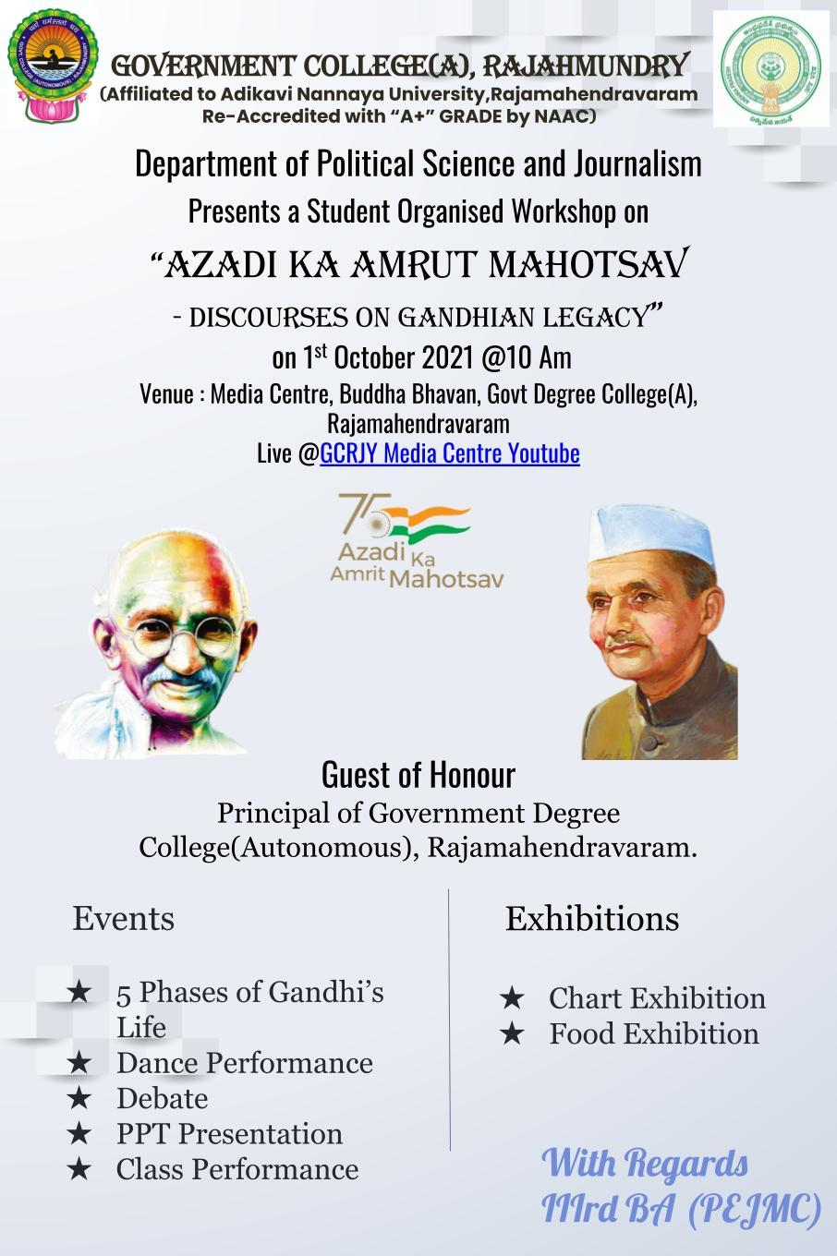

The Webinar was organised by the Students of 3rd BA(PEJMC) in the remembrance of Gandhi and as a part of celebrations for Upcoming Gandhi Jayanti, under the supervision of Department of Political Science, Government College (Autonomous), Rajahmundry. As mentioned in the Invitation the Workshop is availed through Live to Students in Youtube due to Covid-19 Norms. The Students are appreciated for their Efforts and TeamWork in organising the Event despite the Hurdles of the Pandemic.

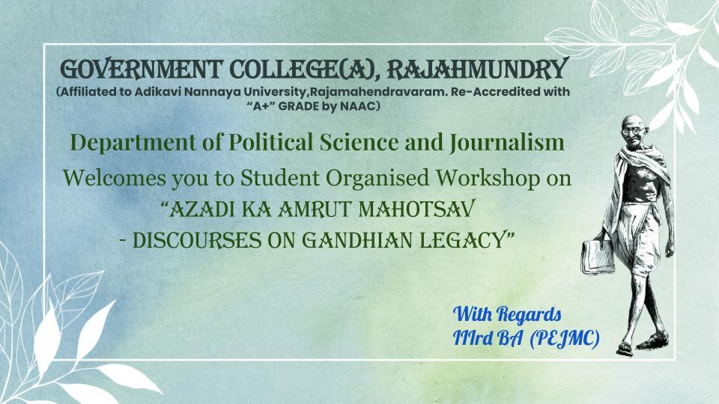

The Workshop :
The Workshop is initiated with Welcome Notes by T.Satwika. The Students of 3rd BA (PEJMC) initiated the Workshop with Vandemataram. Then the Principal of Government College (A) Rajahmundry, honoured the stage to address the Audience. He appreciated the Department and Faculty members in filling Young Minds with innovation and for developing Skill and Capability in them till date,in such a way that they Organised a Workshop. The Students planned various activities to engage the Audience and to promote the Ideology of Gandhism into their fellow Young Minds.

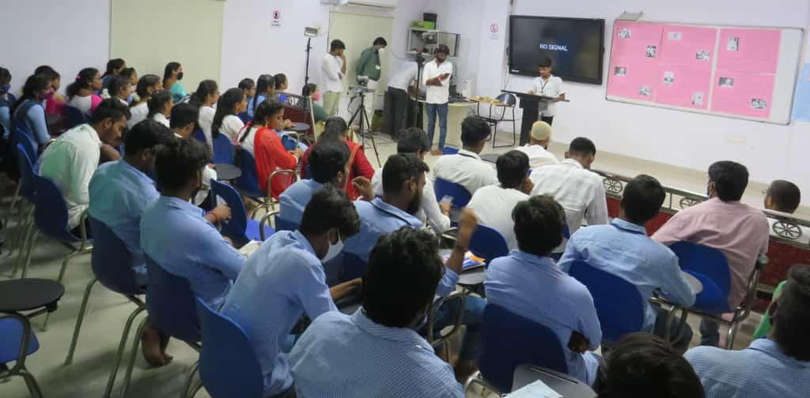

Events (Overview) :

- Chart Exhibition => All the Main Life Events of Gandhi are detailed on Various Charts and are explained by Students. The Charts also contained Pictures of Gandhi during those Periods of Time. The Topics ranged from Gandhi’s Birth to Assasination and Everything in Middle, and went through a Crystal Clear Explanation.

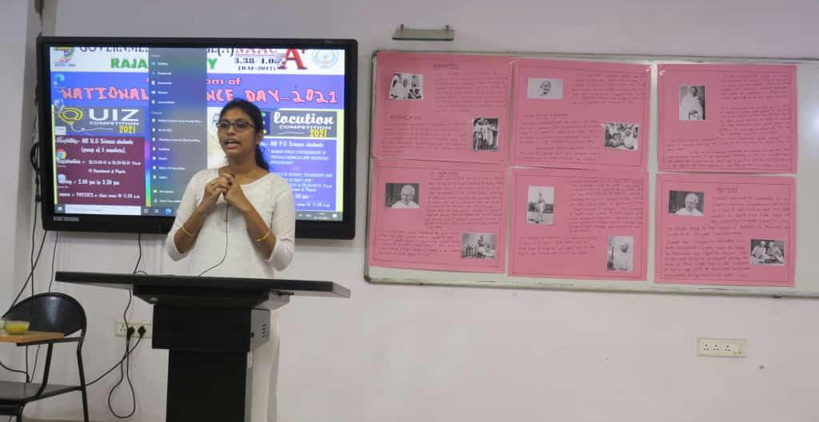
- Food Exhibition => The Gandhian Food is displayed and Back Stories of some Food Items are explained by Students. This promoted the Thought process of MAHATMA. He preferred Dal, Brown Rice, Brinjal, Yogurt, Roti and Groundnut replacing all other Foods that might directly or indirectly hurt any living Soul.

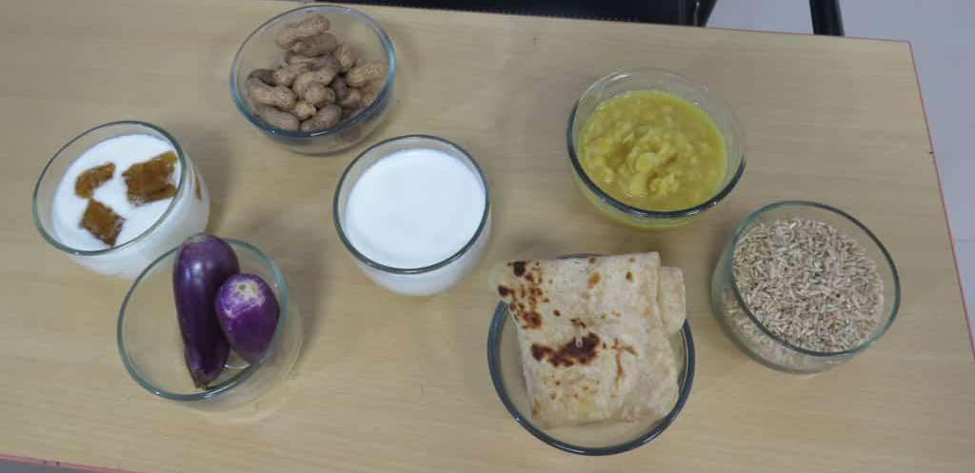

- Speeches => The Students detailed all Important and Impactful Life Events and Incidents of Mahatma Gandhi’s Life on the basis of Gandhi’s Childhood, Education, Life in South Africa, Return to India, Role in Politics, Role in Independence and Assination.

- PPT Presentation => Students presented a PPT Show briefing the Legacy of Mahatma Gandhi, also displayed the Turning Points throughout Gandhi's Life. The PPT was impactful with Quite a Collection of Images of Gandhi during these Events. They also explained the Biographical Movie of Gandhi (Gandhi-1982).

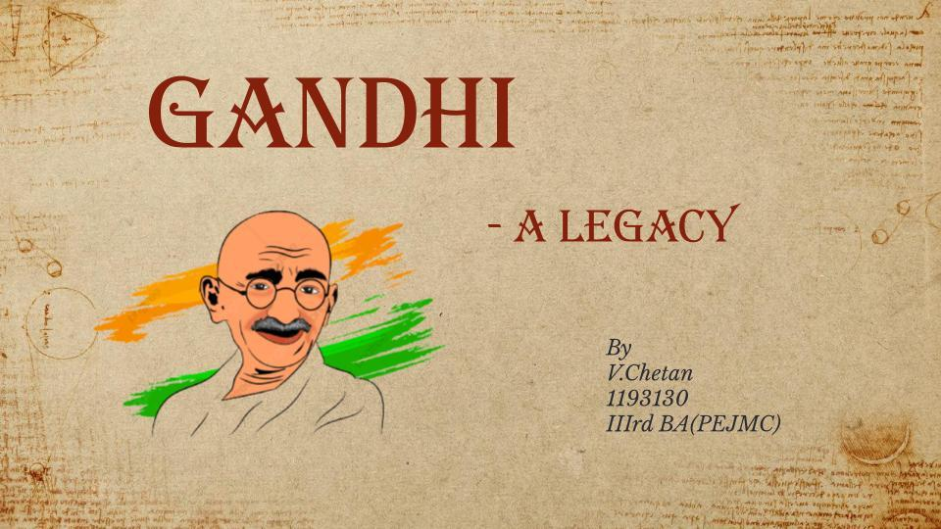

- Dance Performance => The Students put on quite a show with an Empathic and Pompous Dance Performance. They Displayed Gandhi’s 3 Freedom Movements and were hugely applauded for their Efforts and Determination. Student impersonating Gandhi (by Looks) stood out as a Special Attraction to the Event.

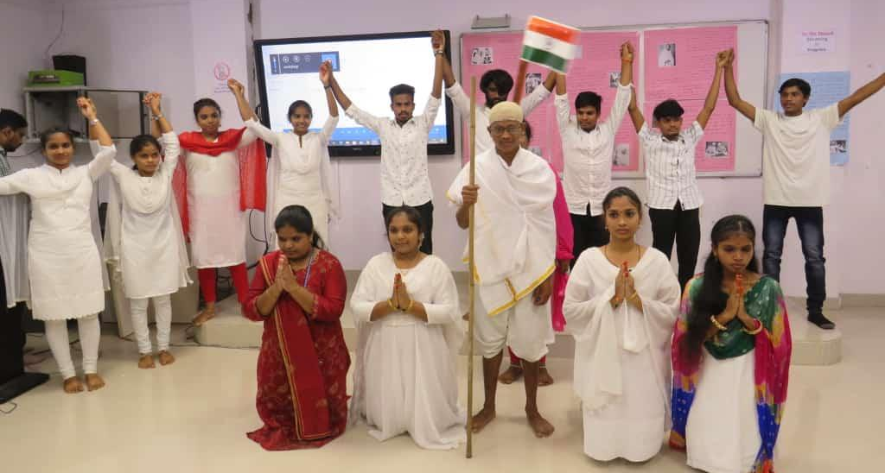

- Debate => The Students were split into 2 Groups and debated on “Relevance of Gandhian Ideology in Present Times”. The discussion took 3 Rounds with Mr.Surya Narayana, an Alumni of GCRJY as the Debate Moderator. The Discussion went in many ways with lots of exchanges between 2 teams but concluded on Good Notes on Gandhian Ideology.
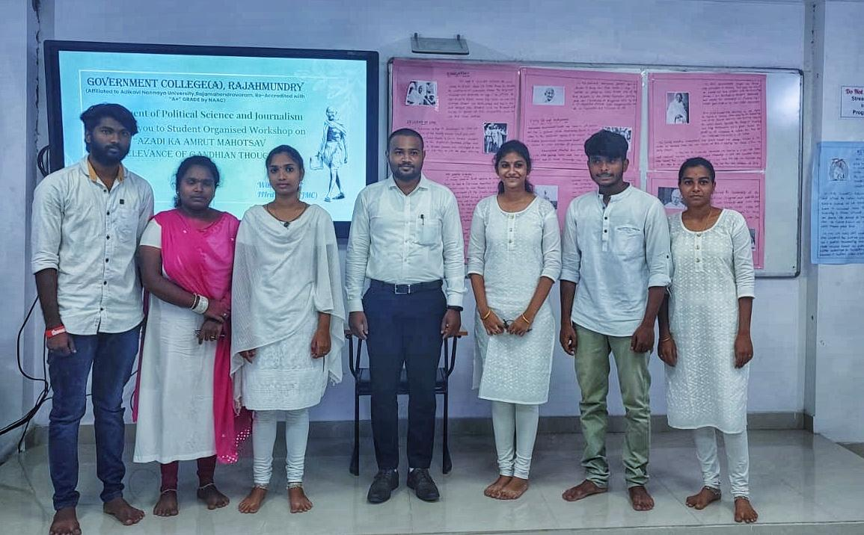
- Skit => The Skit started Grand and Ended Quite Monumental. The skit starring Gandhi is a Massive Cornerstone in the Success of the Event. The Students displayed every single Major Life Incident of Gandhi. The Students really did quite a work Impersonating Gandhi.
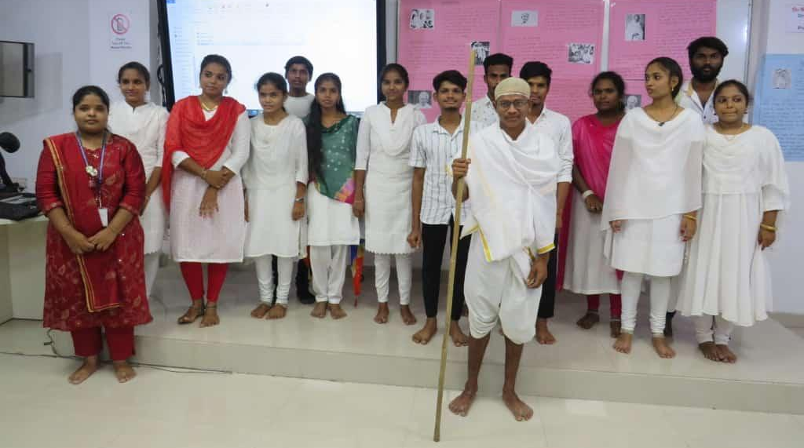

Then, The Students concluded the Workshop leaving the Audience in an Amazing Spellbound Experience. Later the Audience and Faculty are requested to forward their Views on Gandhian Ideology and their Feedback on the Workshop.
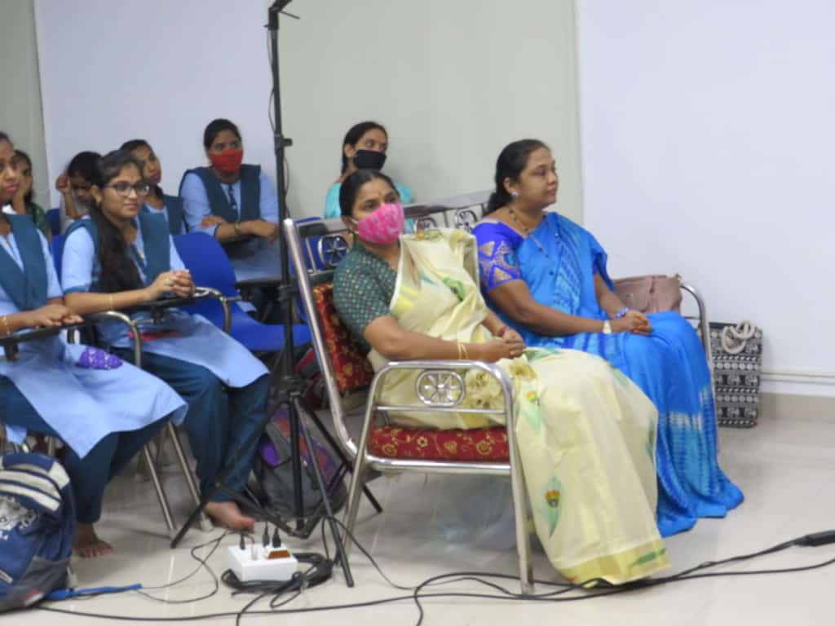
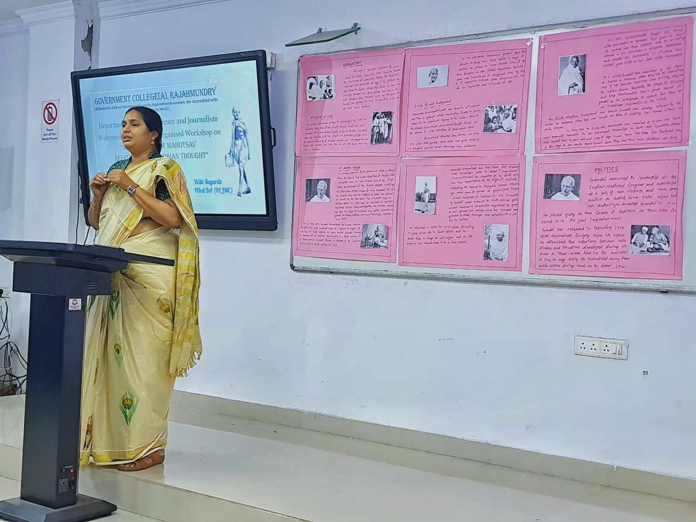

The Vote of Thanks is expressed by the Students of 3rd BA(PEJMC) after the Opinion session of the Audience, The Students and Faculty members are appreciated for their presence and Active Participation. Dr. Sita Maha Lakshmi along with the Department of Political Science are appreciated for their Constant Support, Immense Dedication and Commitment toward the development of the Skills of Students in Co-Curricular and Extra-Curricular Activities.

Public Reach :
The Workshop is well-planned and Co-ordinated by Students. The Workshop is made available Online with the Youtube Live Link.

Youtube Live Viewers : 200+
For a Student Organised Workshop, This can be termed as Successful.

Feedback (Source- Audience) :

- Gandhism is and always will be Remarkable and Iconic Ideology, Gandhi’s Economic Strategy is the best one that I’ve come across.
This is also my first time coming across a Student organised Workshop in GCRJY, It was Great and I’m looking forward to seeing more such Student Activities.
-P.S.Sastry, Head of English Department, GCRJY.
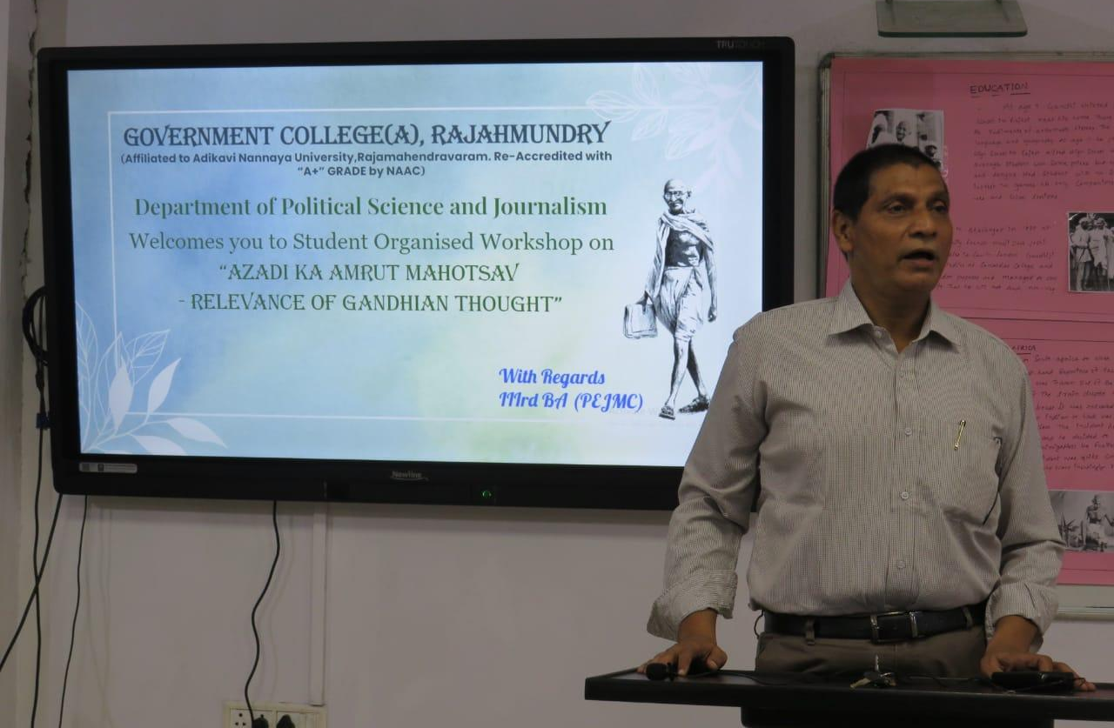

- Kudos to the Students of 3rd BA(PEJMC) on the successful completion of the Workshop. Gandhi is not and never was a Name, it is a Revolution that put us in the Freedom that we enjoy today. Students taking the initiative and making it possible is the Best Accomplishment for the Teachers who Mentored them to this Heights.
-P.Babjee, Controller of Examination Cell, GCRJY.

- This lecture traced the Evolution of Diversified thinking and Emphasized the current Status of the Society. Then it gave the Solution for that Issue by suggesting to follow in the Footsteps of Mahatma. Gandhian Ideology is simple to Listen, it takes Focus and Concentration to live in it. But, if could successfully implement this as your life style, you will row selfless and work for the betterment of Others(Society)
-S.Trivikram, Lecturer in Journalism, GCRJY.
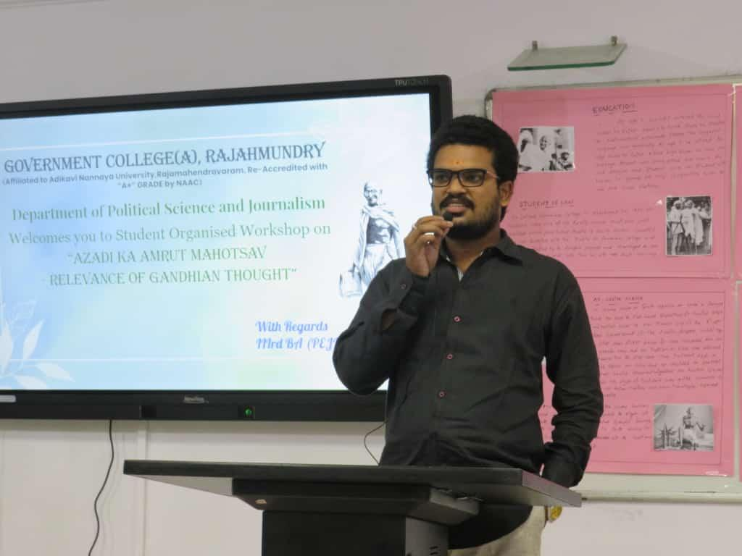

- I am very happy to hear that Students took the Initiative on Celebrating Gandhian Ideology because Gandhi is an Ocean, during every part of his Life we can find motivating Factors. Sometimes these motivating factors also became driving Factors of Life For Many. Wherever in the World we go, We can proudly say that We are born in the Country of Gandhi. Students taking up such a Task and successfully completing it is Appreciable. The Debate Discussion grabbed my attention with all much needed Changes inPresent Society for it’s Betterment.
-Mr.Sateesh, Lecturer in Social Work, GCRJY.
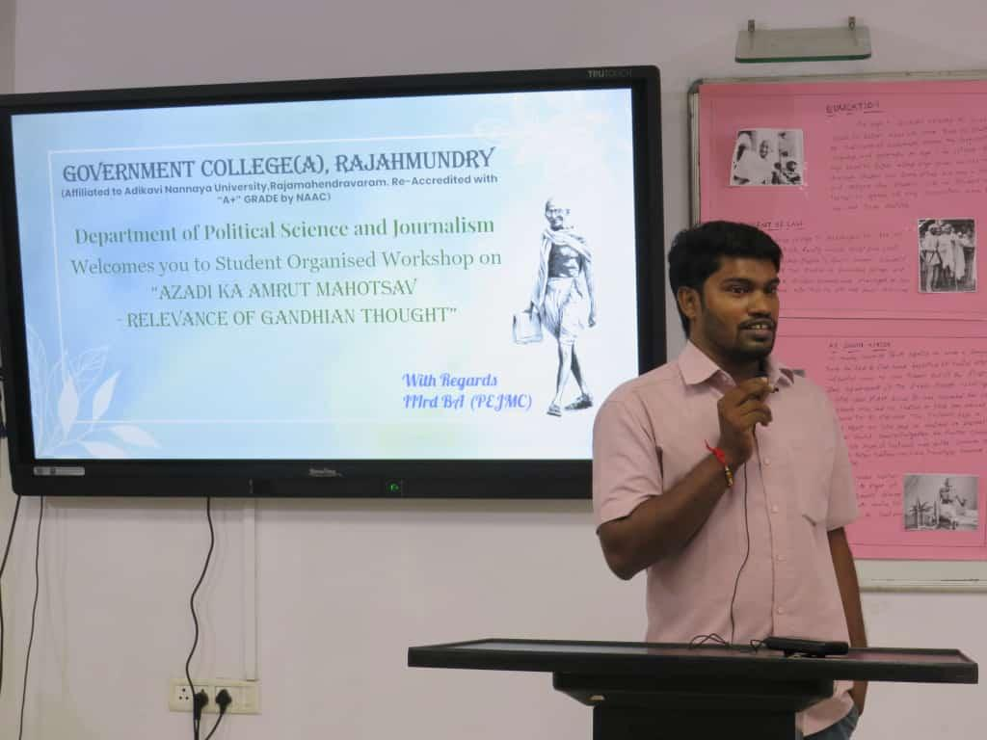
- The Incharge Principal Mr. Prabhakar Sir praised the Students on the Successful Completion of The One-Day Webinar and appreciated the Department for providing all the Support in Growth of the Students
