 | GOVERNMENT COLLEGE (AUTONOMOUS) RAJAHMUNDRY | Program  &  Semester  II B.A/BSC/B.COM (SEM-IV)
Course  Code | TITLE OF THE COURSE  MULTI DISCIPLINARY COURSES :  BASICS STATISTICS
 | Hours Allocated: 30 hrs | L | T | P | C
Pre-requisites: | Basic knowledge in statistics | 0 | 4 | 0 | 0

Syllabus
Unit I: Meaning, scope and limitations of Statistics Collection of data: Primary and Secondary, Classification and Tabulation, Construction of frequency distribution. Graphical Representation: Histogram, Bar, Pie and Frequency polygon.
Unit II: Measures of Central Tendency: Features of good average, Arithmetic Mean, Median, Mode. Empirical relationship between Mean Median and Mode
Unit III: Measures of Dispersion: Range, Quartile Deviation (QD), Mean Deviation (MD), Standard Deviation (SD), relationship between QD, MD and SD.

Blue Print :

Model blue print for the Question Paper setter
Unit | Essay Questions | Marks allotted to the Unit/Chapter
I | 3 | 14
II | 3 | 14
III | 2 | 07
Multiple Choice Questions
I | 5 | 05
II | 5 | 05
III | 5 | 05
Total including choice | 8 Questions + 15 MCQ | 50

GOVERNMENT COLLEGE (A) RAJAMAHENDRAVARAM
II YEAR /Semester-IV
MDC Paper - BASICS STATISTICS
MODEL QUESTION PAPER - 2025-26
Time: 2 hrs Max Marks: 50
SECTION-A
Answer any FIVE questions 5 x 7 =35M
- Explain Collection of data and its types?
- Explain Scope of statistics?
- Find arithmetic mean to the following data?
x | 1 | 2 | 3 | 4 | 5
F | 5 | 8 | 10 | 12 | 6
- Calculate mean deviation the following data?
Class interval | 10 – 20 | 20 – 30 | 30 – 40 | 40 – 50 | 50 – 60
Frequency | 5 | 10 | 15 | 10 | 5
- Explain the Histogram and its example diagram?
- Compute Standard deviation of the values 10,6,8,12,20?
- Designing for using Questionnaire and a Schedule?
- Explain the Median and its ungrouped and grouped data?
SECTION-B
Answer all of the questions. 15 x 1 = 15M
1. Before any procedures for _______are established, the purpose and the scope of the study must be clearly specified.
- Data analysis b) Data tabulation c) Data collection d) Data selection
2. The classification of data according to location is what classification:
- Chronological b) Quantitative c)Qualitative d)Geographical
3. A function very similar to that of sorting letters in a post office is :
- Mean b) Standard deviation c) Classification d)Mean deviation
4. Editing would also help eliminate inconsistencies or obvious errors due to treatment.
- Characteristic b)Arithmetical c)Calculation d)Tabulation
5. When an in vestigator uses the data which has already been collected by others, such data is called _____.
  - Primary data b) Collected data c) Processed data d) Secondary data
6. In statistics _______classification groups the data according to locational differences among the items.
- Chronological b)Geographical c)Regional d) Alphabetical
7. The first step in tabulation is:
- Footnote b) Source note c) Captions d) Classification
8. A systematic arrangement of data in rows and columnsis:
- Table b) Tabulation c) Body d) All the above
9. One dimensional diagram is:
- Line diagram b) Rectangles c) Cubes d) Squares
10. Type of bar diagramis:
- Pictogram b) Sub divided diagram c) Line diagrams d) Pie diagram

11. The median of a frequency distribution is found graphically with the help of:
- Histogram b) Frequency curve c) Frequency polygon d) Ogive
12. The classification of data according to location is what classification:
- Chronological b) Quantitative c)Qualitative d)Geographical
13. Mean deviation which is calculated is minimum at:
- Mean b) Median c) Mode d) All the three
14. Find the range for the following data
14,16,16,14,22,13,15,24,12,23,14,20,17,21,22,18,18,19,20,17,16,15,11,12,21,20,
17,18,19,23.
- 13 b)12 c) 14 d) 16
15.Find the median of the run made by a player in 5 T20 matches, 55,44, 21, 35, 45
- 55 b) 21 c) 44 d) 35

BASICS STATISTICS
UNIT-I
DEFINITION OF STATISTICS
The science of collecting, analyzing, presenting and interpreting data. Governmental needs for census data as well as information about a variety of economic activities provided much of the early impetus for the field of statistics. Currently the need to turn the large amounts of data available in many applied fields into useful information has stimulated both theoretical and practical developments in statistics.
MEANING OF STATISTICS
- The word “Statistics” has been derived from Latin word “Status”.
- Statistics is a branch of mathematics dealing with the collection, analysis and interpretation of numerical data.

ORIGIN OF STATISTICS
In the beginning statistics was used by kings only for collecting information about states and also they used to collect the data regarding the incomes and expenses ect of the people in the state.
So, this subject is developed as a ‘Kings Subject’ or as ‘Science of kings’. But now a day’s its scope has increased and widened. Statistics is now used in almost in all the fields like Business, Economics, Social sciences, Politics, Planning etc…
IMPORTANCE AND SCOPE OF STATISTISCS
The fields of statistics is the science of learning from data. Statistics knowledge helps you use the proper methods to collect the data, employ the correct analyses and effectively present the results. Make decisions based on data and make predictions. Statistics allows you to understand a subject much more deeply.
- Statistics and Planning:
Statistics is indispensable in planning. Almost all organizations in the Government are using appropriate statistics methods and techniques for planning and formulating policy decisions.
- Statistics and Mathematics:
Statistics is intimately related and essentially depend on mathematics. In general statistical techniques are derived from theory of probability and applications advanced mathematics.
- Statistics and Business:
Every decision in business is made with the help of statistical data and statistical methods. Almost all business activities depend on statistical techniques for studying, analyzing and forecasting demand of the product and behavior of the consumer mot effectively. The success of a businessman depends upon the accuracy and precision of forecasting the economic variables. If the predictions are wrong, then it leads to heavy loss. Hence the businessman is supposed to collect relevant statistical data about his future plan of production in advance.
- Statistics and Medical Science:
Statistical tools are essential in medical science to observe the facts relating to causes and occurrence of diseases by collecting and analyzing the related information. This results in the better usage of drugs and medicines.
- Statistics and Education:
Statistics has many number of applications in education. In statistics is mostly used to solve the problems. Statistics in education is used for analyzing efficiency and progress of the students and also useful for improvement of teachers performance.

DATA COLLECTION
Data collection:Statistics investigation is based on systematic collection of data. The reliability of conclusions drawn from the sample data depends to a great extent on the quality of the data. The systematic planned and meaningful way of collecting information is know as collection of the data. The methods of collection of the data depends on various aspects such as objective, scope and nature of the problems under study. The data can be collected from two main sources which will be discussed below.

Primary and Secondary Data:Statistics data can be collected generally in the following two ways
- Primary data
- Secondary data

- PRIMARY DATA:
Primary data are those statistics data which are collected for the first time are original in nature. Primary data are collected originally by the authorities who are required to collect them. The source from which primary data are collected is called primary source.
The primary data may be collected by any one of the methods:

- Direct personal interview
- Indirect personal interview
- Mailed questionnaire method
- Information from local agents

- SECONDARY DATA:
The secondary data is one which is collected by some
earlier agency but is used and annalysed by any other for its
own use. There are several sources of secondary data which
are discussed below
The sources of secondary data can be broadly classified in two categories:
- Published sources
- Unpublished sources
DESIGNING A QUESTIONNAIRE AND SCHEDULE:
1. Questionnaire:
Collection of the data through questionnaires is the most popular method for collecting primary data. A questionnaire is well prepared list of questions regarding the enquiry of the survey. In this method a questionnaire is sent to various respondents, they answer the questions and return the questionnaires. This method is extensively employed in various economic and business surveys.
2. Schedule:
In this method, a team of enumerators is selected training will be given to them. Now the enumerators fill up the schedule. The difference between schedule and questionnaires methods is that schedules are being filled by enumerators whereas questionnaires are to be filled by respondents. A special team of enumerators is appointed for recording the answers given by respondents. The enumerators explain clearly the objective of survey, the definitions of survey, the definitions of basic concepts and rules to the respondents and record their responses. Census is usually conducted by using this method in the world.
CLASSIFICATION OF DATA
Classification of data:
Classification of data means arranging the collected data into different classes or groups on basics of their similarities and which have close resemblance. This helps in separating the characters have similarities and dissimilarities. A group or a class has to be determined on the basis of the nature of Data and the purpose for which it is going to be used. For example, the data on households can be classified on the basis of age, religion, education, income, occupation, ect.
Methods of classification
1. Classification according to ATTRIBUTES
2. Classification according to VARIABLES

1. Classification according to ATTRIBUTES:
An attributes is a qualitative characteristics which can be measured quantitatively only as presence or absence of the characteristic. For example, the sex cannot be measured quantitatively, then we can classify into how many male persons and female persons are present.
1. Simple Classification
2. Manifold Classification
2. Classification according to VARIABLES:
Variables are quantifiable characteristics of data which can be measured numerically. Examples are age, height, weight, marks, wages, etc. In this form of classification, the data is shown in the form of a frequency distribution.
1. Unvariate frequency distribution
2. Bivariate frequency distribution
3. Multivariate frequency distribution
TABULATION OF DATA
Tabulation of data:
The tabulation of data may be defined as the logical and systematic organization of statistical data in rows and columns. It is designed to simplify presentation and facilitate analysis.
1. Simple and Complex tables
2. General purpose tables
3. Special purpose tables

1. Simple and Complex tables:
These types of tables are prepared to show the importance characteristics of the collected data.
2. General purpose tables:
This type of tables are prepared to store information and contain wide range of information relating to a specified subject.
3. Special purpose tables:
These tables are constructed with a specific point and are very useful for the purpose of comparison. These tables are also called text tables.

DIAGRAMMATIC AND GRAPHICAL REPRESENTATION OF DATA
Diagrammatic and Graphical representation of data:
Diagrammatic and graphical representation is a technique of presenting a numerical data through simple diagrams like bars, circles, pie, histogram & frequency polygon ect. This kind representation is most attractive and appealing way to represents statistical data. This is only a representation brings out hidden facts and relationships.

One Dimensional Diagrams:
Bar diagrams are the most commonly used diagrams. Shape of a bar is like a rectangle filled with some colour. They are called one dimensional diagrams because only length of the bar matters and not the width
1. Bar Diagram
2. Pie Diagram
1. Bar Diagram:
A bar diagram is diagrammatic representation of a numerical data presents with rectangular bars with heights are proportional to values of the variable under a statistical study.
Types of Bar Diagrams:
The following are the different types of bar diagrams:
(i) Simple Bar Diagram
(ii) Sub divided Bar Diagram
(iii) Multiple Bar Diagram
(iv) Percentage Bar Diagram
(i) Simple Bar Diagram:
Example :The profit (in Rs crore) of a company from 1990-91 to 1999- 2000 are given below
Year | Profit(inRscrore) | Year | Profit(inRs crore)
1990-91 | 35.6 | 1995-96 | 87.2
1991-92 | 46.7 | 1996-97 | 113.1
1992-93 | 39.8 | 1997-98 | 123.6
1993-94 | 68.2 | 1998-99 | 119.7
1994-95 | 93.5 | 99-2000 | 130.8
Representthisdatabyasimplebardiagram.
Solution:The simplebardiagramoftheabovedataisgivenbelow:
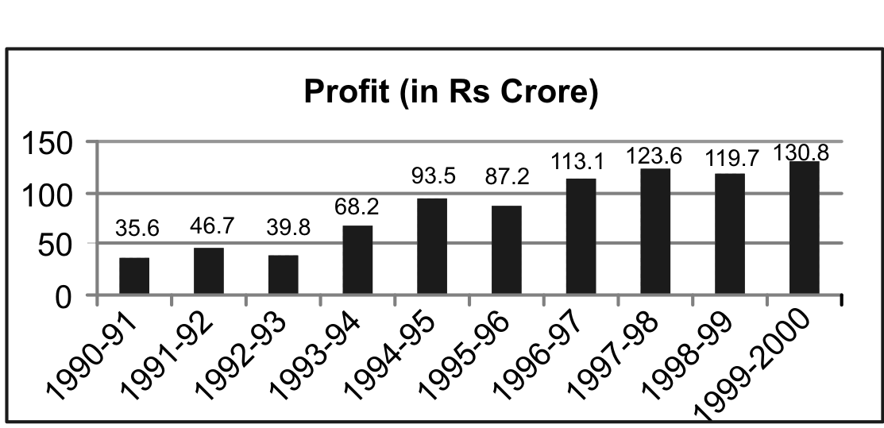
(ii) Sub divided Bar Diagram:
Example : Represent the following data by sub divided bar diagram:
Category | Cost per chair(in Rs)year wise
Category | 1990 | 1995 | 2000
Cost of Raw Material | 15 | 20 | 30
Lab our Cost | 15 | 18 | 25
Polish | 5 | 6 | 15
Delivery | 5 | 6 | 10
Total | 40 | 50 | 80
Solution: First of all, we calculate the cumulative cost on the basis of the given amounts:
Category | 1990 |  | 1995 |  | 2000
Category | Cost  (in Rs) | Cumulative  Cost(in Rs) | Cost  (in Rs) | Cumulative  Cost(in Rs) | Cost  (in Rs) | Cumulative  Cost(in Rs)
Cost of RM | 15 | 15 | 20 | 20 | 30 | 30
L Cost | 15 | 30 | 18 | 38 | 25 | 55
Polish cost | 5 | 35 | 6 | 44 | 15 | 70
Delivery | 5 | 40 | 6 | 50 | 10 | 80
Total | 40 |  | 50 |  | 80
On the basis of above table required sub divided bar diagram is given below:
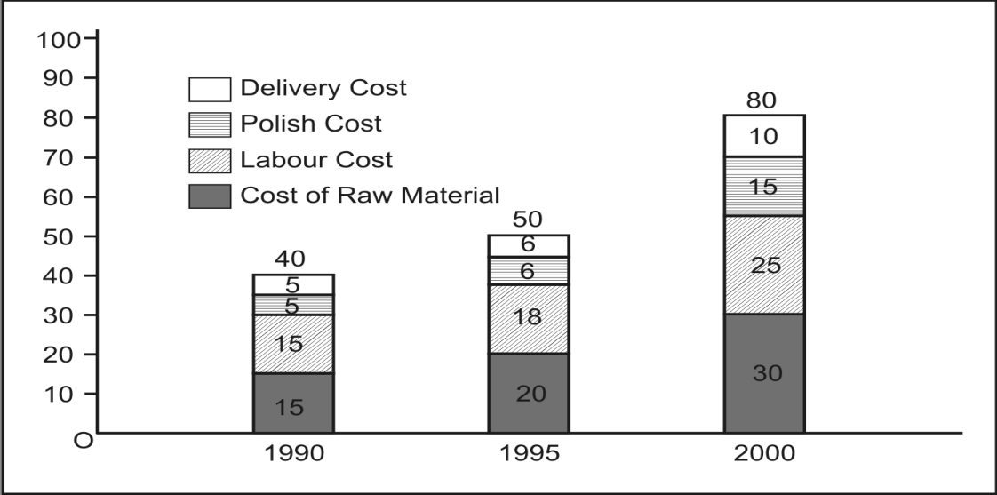
(iii) Multiple Bar Diagram:
Example:Drawthemultiplebardiagramforthefollowingdata.

Year | Sale  (in,000Rs) | Grossprofit  (in‘000Rs) | Netprofit  (in,‘000Rs)
1990 | 100 | 30 | 10
1995 | 120 | 40 | 15
2000 | 130 | 45 | 25
2005 | 150 | 50 | 30
2010 | 200 | 70 | 30
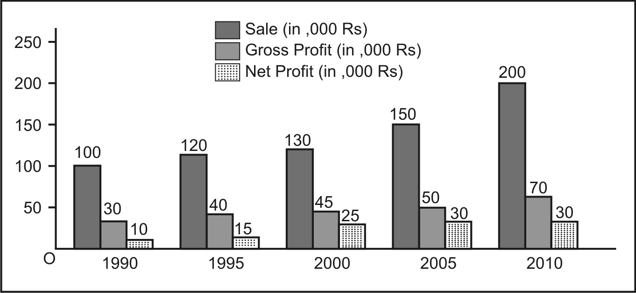
Solution:Multiplebardiagramfortheabovedataisgivenbelow

(iv) Percentage Bar Diagram:
Example: Draw a percentage bar diagram for the following data:
Category | Cost Per Unit (1990) | Cost Per Unit (2000)
Material | 20 | 32
Lab our | 25 | 36
Delivery | 5 | 12
Total | 50 | 80
Solution: First of all percentage and cumulative percentage are obtained for both the years in various category.
Category | Cost Per Unit |  | (1990) | Cost Per Unit |  | (2000)
Category | Cost | %Cost | Cumulative  % Cost | Cost | %Cost | Cumulative  %Cost
Material | 20 | 40 | 40 | 32 | 40 | 40
Lab our | 25 | 50 | 90 | 36 | 45 | 85
Delivery | 5 | 10 | 100 | 12 | 15 | 100
Total | 50 | 100 |  | 80 | 100
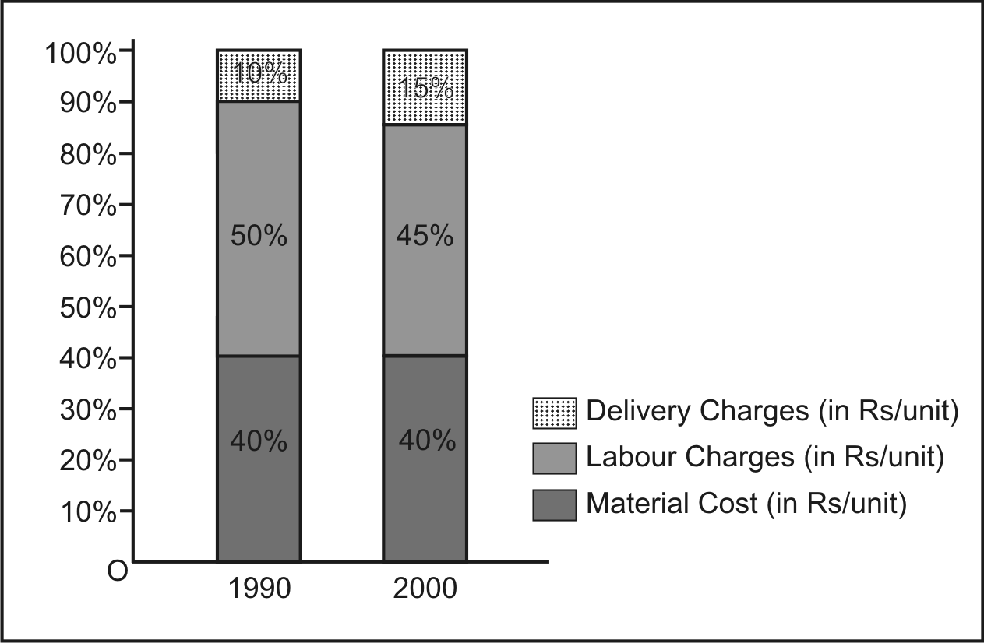
On the basis of above table required percentage bar diagram is given below

2. Pie Diagram
Pie diagram is a diagrammatic representation of different categories of a variable in a circular form. The representation of all categories in different sectors of the circle in accordance with degree of the category is called pie diagram.
Example 1: Draw a pie diagram for the following data:
The suitable diagram in this case is pie diagram. Calculation of degrees and percentages is an exercise for you. On the basis of calculation, pie chart which shows the utilization of 100 prise of income by XYZ Company in year 2009-2010.
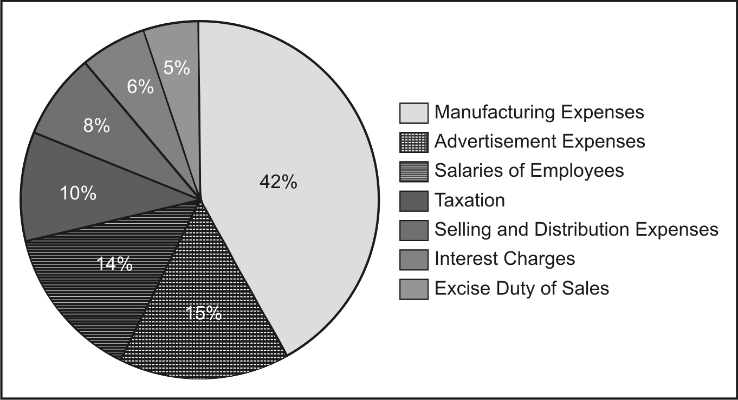
Example 2: Draw a Pie diagram for the following data:
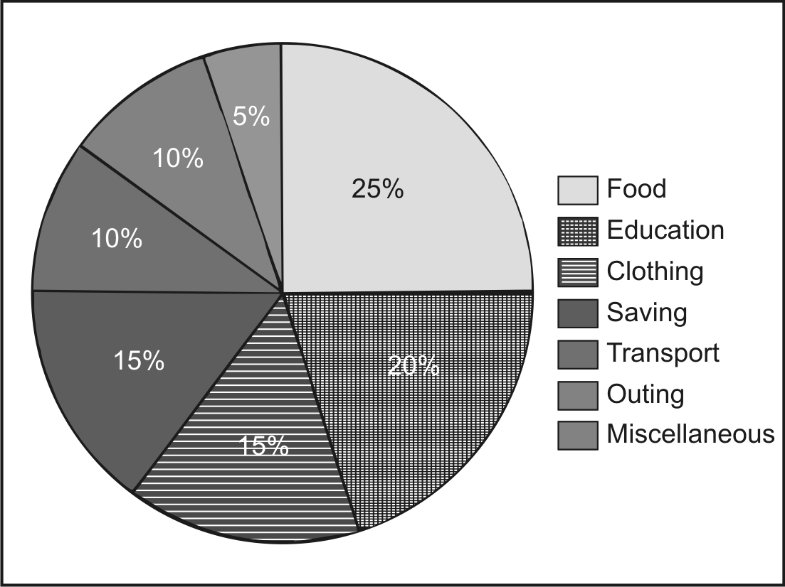
The suitable diagram in this case is pie diagram. Calculation of degrees and percentages is an exercise for you. On the basis of calculation, pie chart which shows the expenditure of a family on different items is shown below

Two Dimensional Diagrams:
In one dimensional diagrams only length of the bar is importantand comparison of bars are done on the basis of their lengths only, while in two dimensional diagrams both length and width of the bars are considered
1. Histogram Diagram
2. Frequency polygon Diagram
1. Histogram Diagram
The graph usually drawn to represent a frequency distribution is called a Histogram. A histogram is a set of rectangles (vertical bars) each proportionateinwidthtothemagnitudeofaclassintervalandproportionatein area to the number of frequencies concerning the classes’ intervals. In a histogram, the variables (class-intervals) are always shown on X-axis and the frequencies are taken on the Y-axis.
Example: Present the following information in the form of a Histogram
Marks | 0-10 | 10-20 | 20-30 | 30-40 | 40-50
Number of Students | 16 | 36 | 70 | 50 | 28

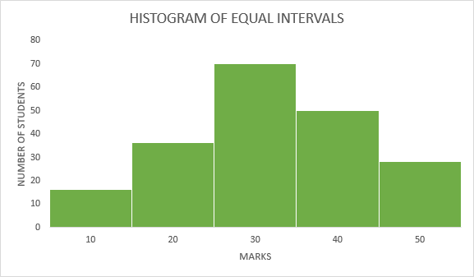
Solution:

2. Frequency polygon Diagram
Polygon means ‘many-angled’ diagram. This is another way of depicting a frequency distribution graphically. It facilitates comparison of two or more frequency distributions. Frequency polygon can be drawn either from the histogram or from the given data directly.
The procedure for the construction of a frequency polygon by histogram is to first draw the histogram, as explained earlier, of the given data. Then, put a dot at the mid-point of the top horizontal line of each rectangle bar and join these dots by straight lines.
Example: Draw a frequency polygon for the data below with a histogram.
Cost of Living Index | Number of weeks
140 - 150 | 2
150 - 160 | 8
160 - 170 | 14
170 - 180 | 20
180 - 190 | 10
190 - 200 | 6
Total | 60
Solution: To plot a frequency polygon with a histogram, we need to follow these steps to construct a histogram:
Cost of Living Index | Number of weeks | Classmark
140 - 150 | 2 | 145
150 - 160 | 8 | 155
160 - 170 | 14 | 165
170 - 180 | 20 | 175
180 - 190 | 10 | 185
190 - 200 | 6 | 195
Total | 60

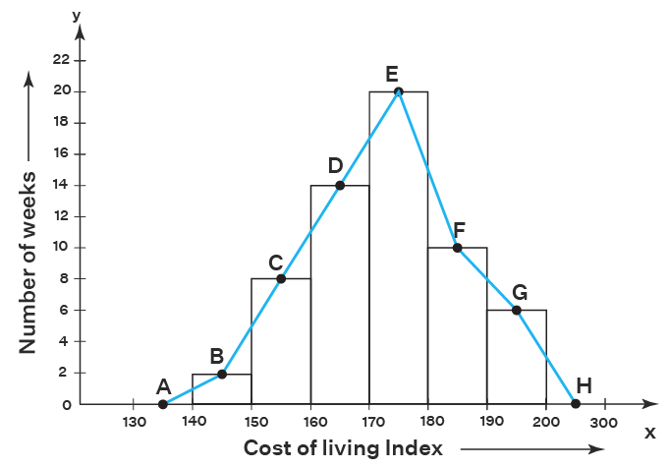

BASICS STATISTICS
UNIT-II
MEASURES OF CENTRAL TENDENCY
Measures of Central Tendency:
Measures of central tendency or measures of location give an idea about the concentration of the value in the central part of the distribution. A measure of central tendency is a statistical average or a single value which represents entire distribution.
The following are some important measures of central tendency.
1) Arithmetic mean
2) Median
3) Mode

1) ARITHMETIC MEAN:
Arithmetic mean of a set of observations is the sum of all observations divided by the number of observations. It is denoted by$\overline{X}$.

Arithmetic mean 𝑋̅ = Total of all values
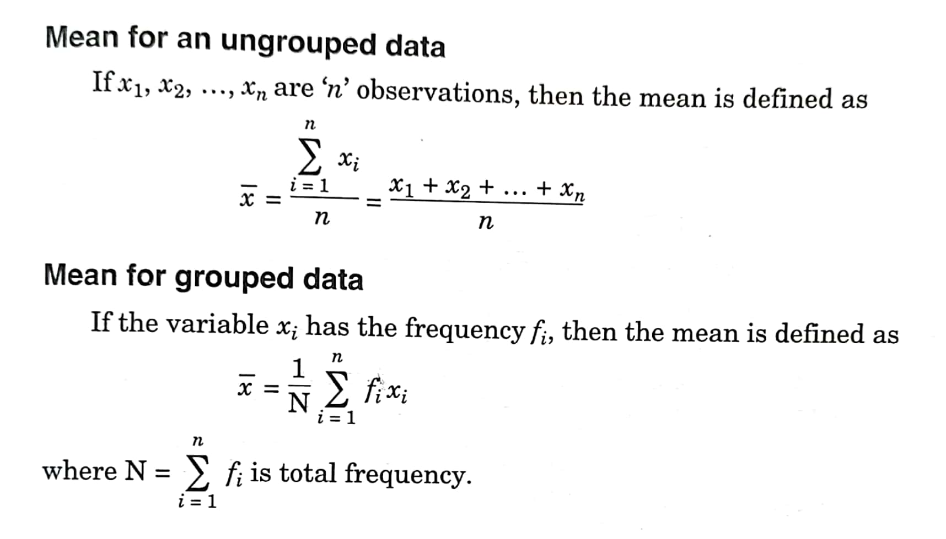
Number of the observations

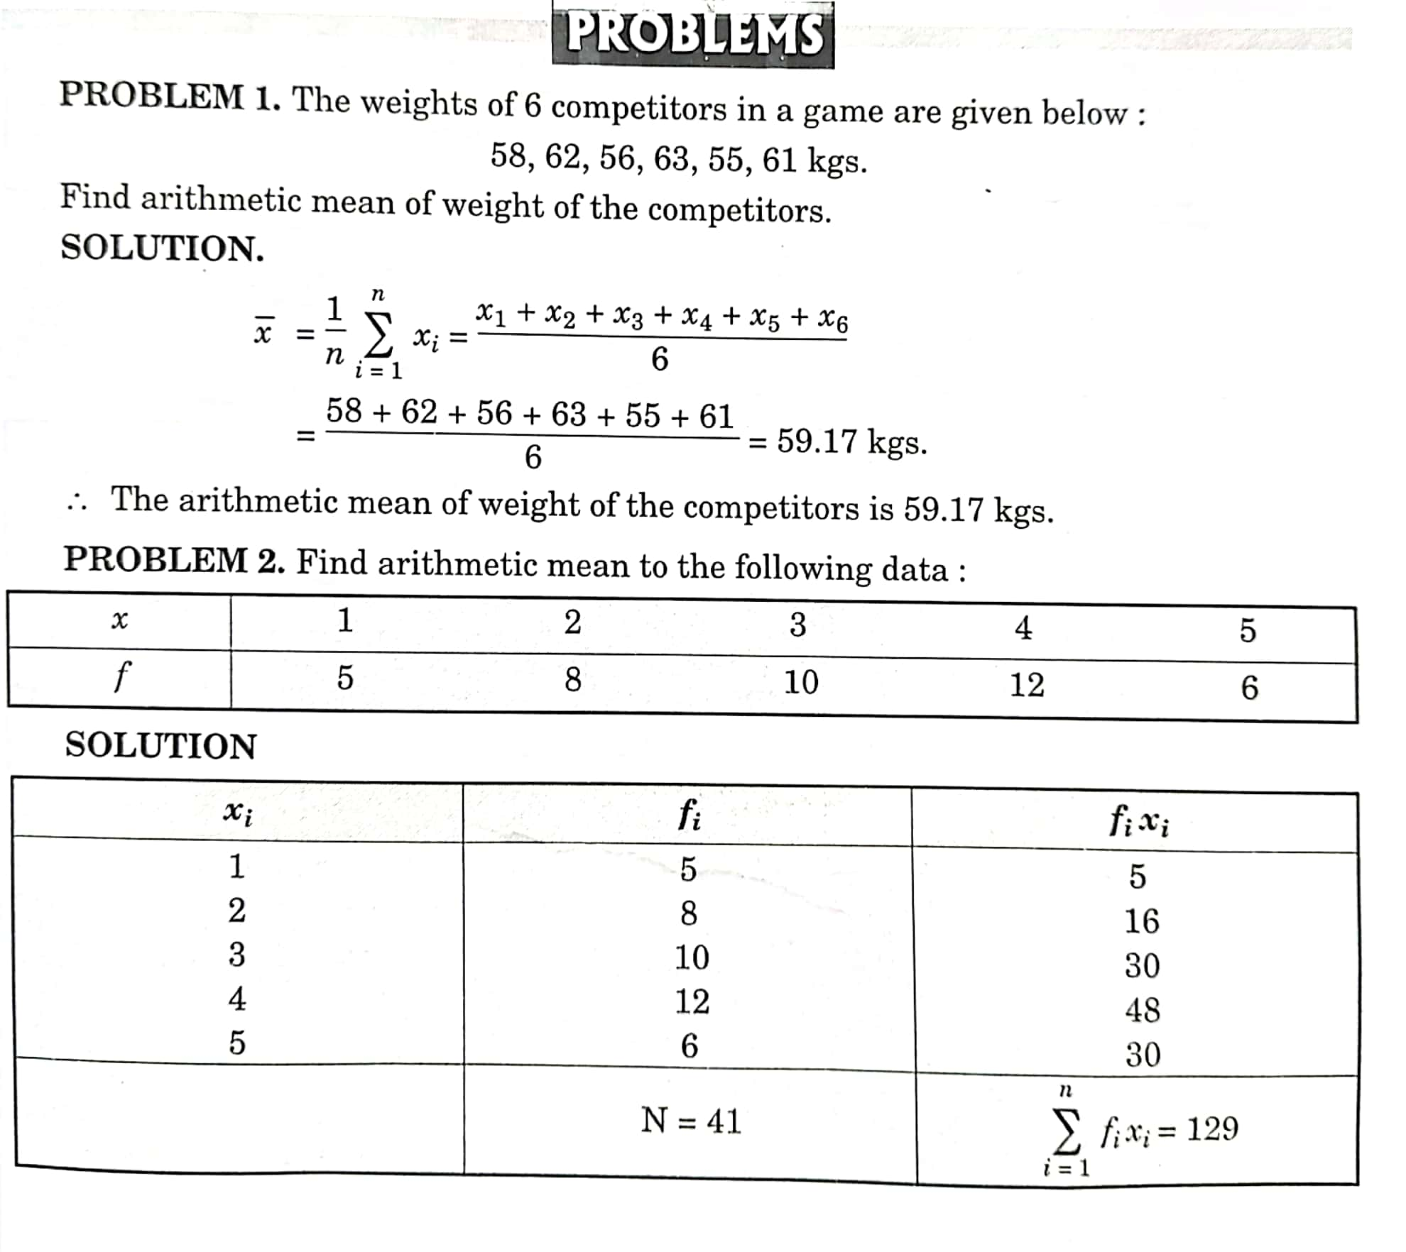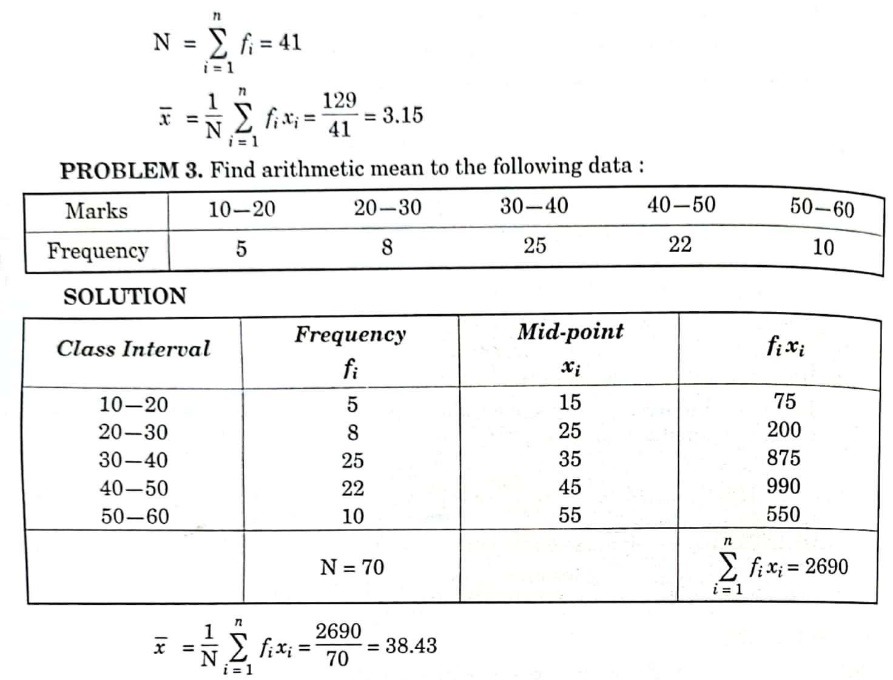

2) MEDIAN:
Median of a distribution is the value of the variable which divides it into two equal parts, i.e., median is the the middle value of the distribution. 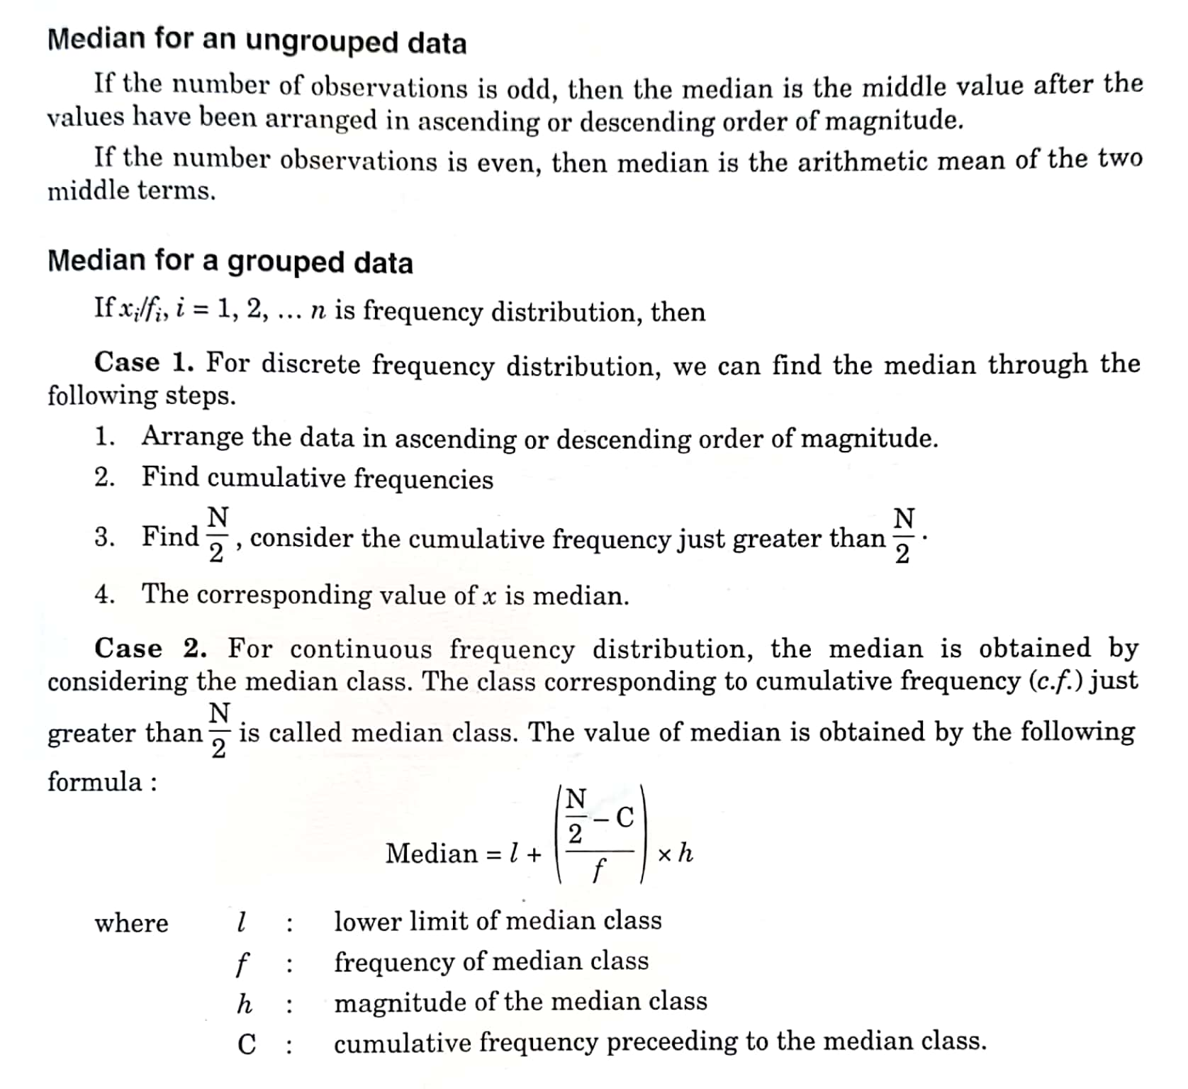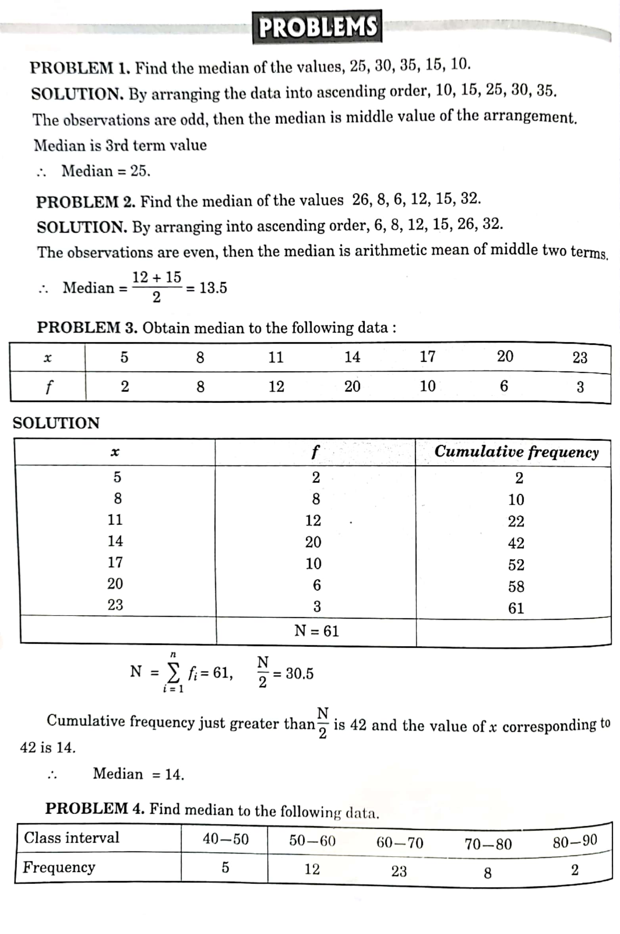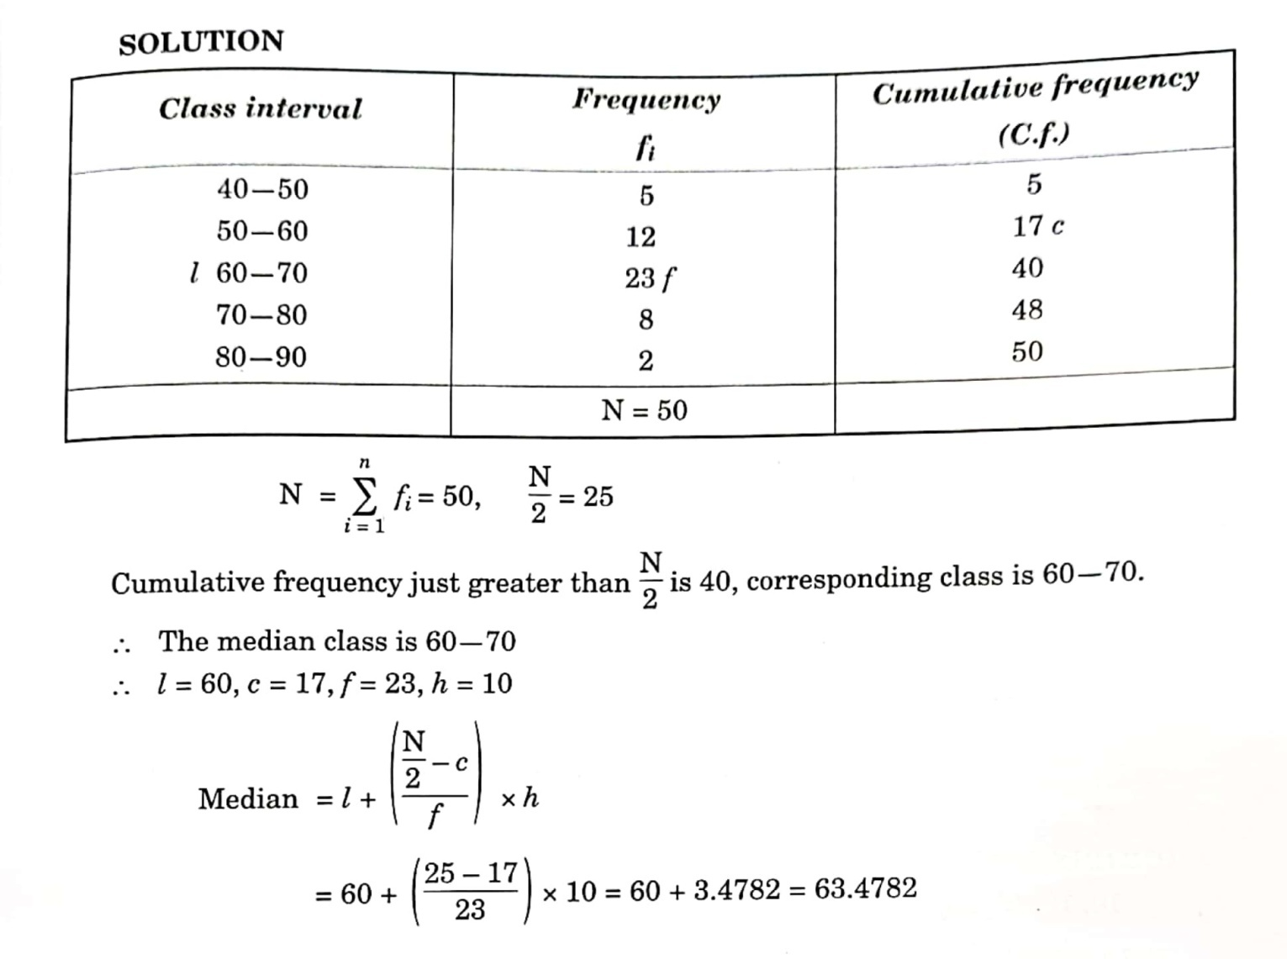
3)MODE:
Mode is defined as the value which occurs most frequently in a set of observations. 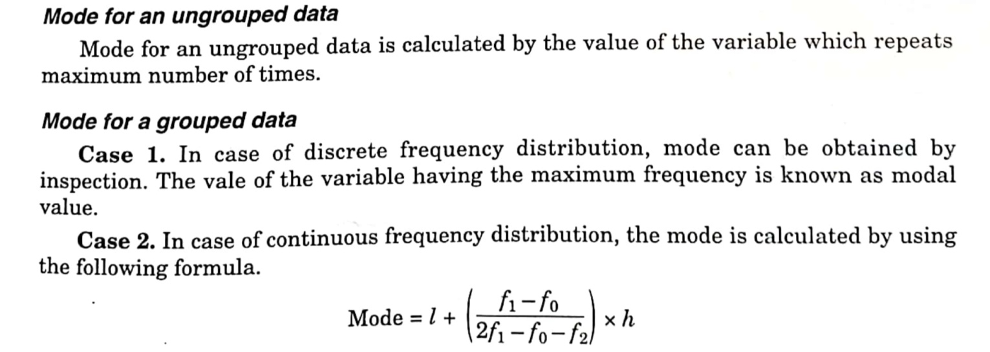
Where , l : lower limiot of model class.
h : width of the modal class interval.
f₁ : frequency of model class
f₀ : frequency of preceding the model class
f₂ : frequency of succeeding the model class
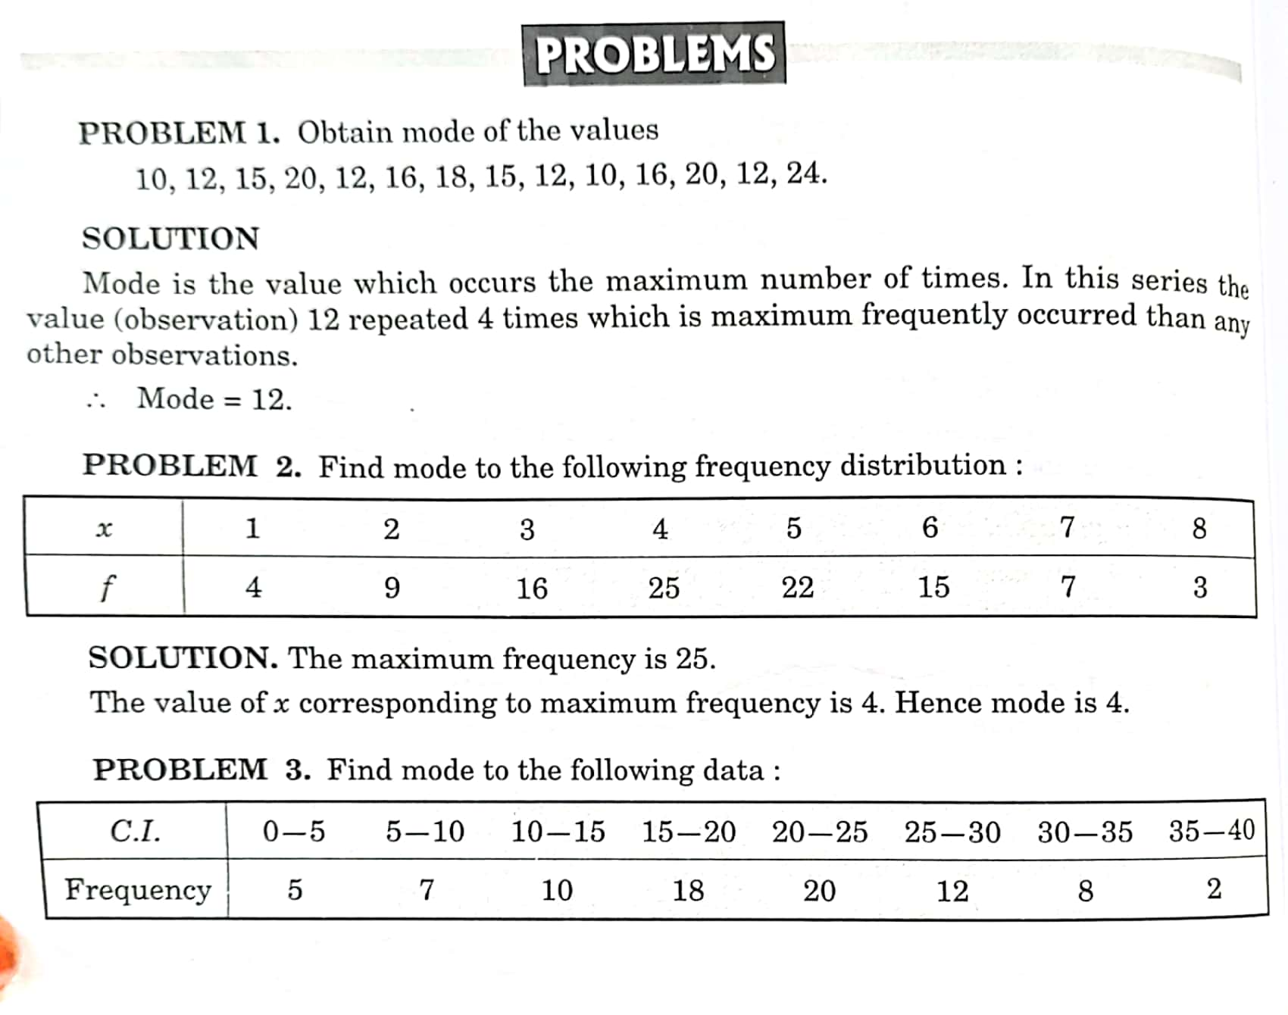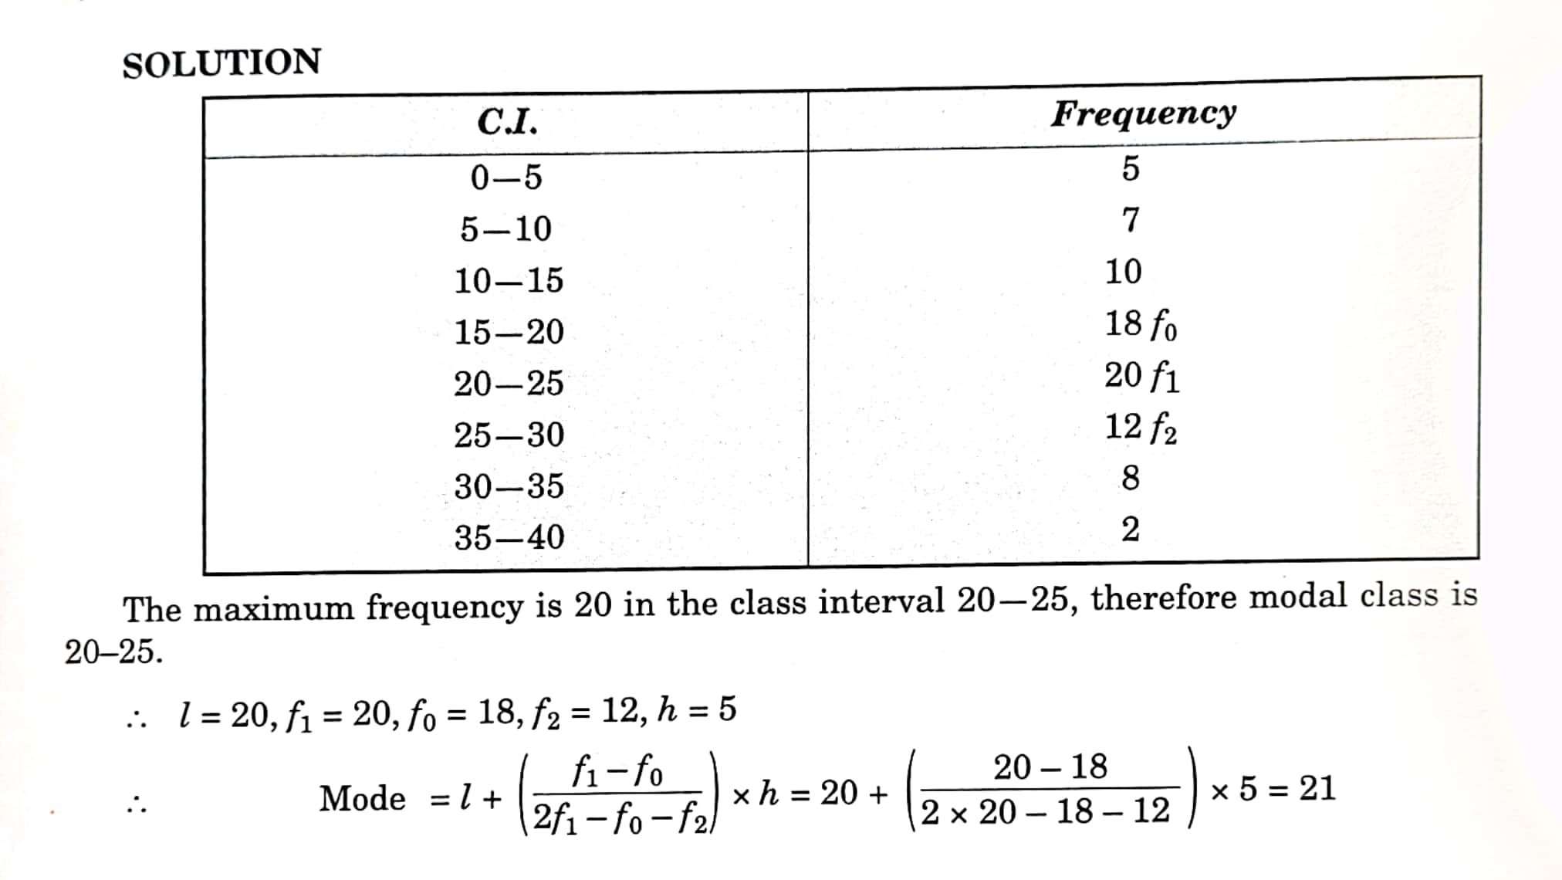
BASICS STATISTICS
UNIT-III
MEASURES OF DISPERSION
MEASURES OF DISPERSION:
Dispersion means scatteredness. Measures of dispersion study about the homogeneity or heterogeneity of the distribution.
The following are the measures of dispersion
1. Range
2. Quartile deviation (QD)
3. Mean deviation (MD)
4. Standard deviation (SD)
1. RANGE:
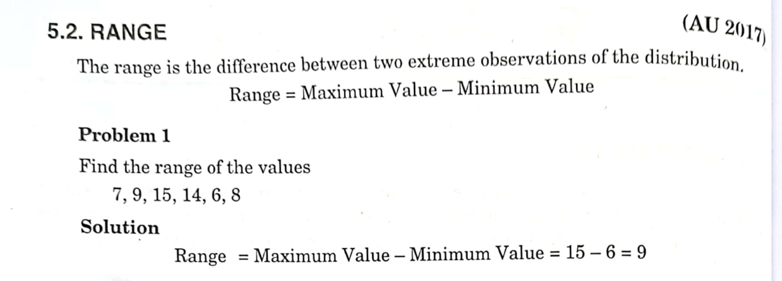
2. QUARTILE DEVIATION (QD):
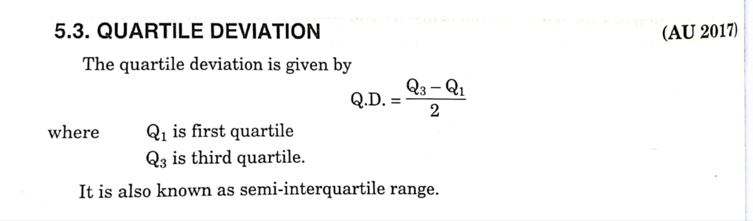
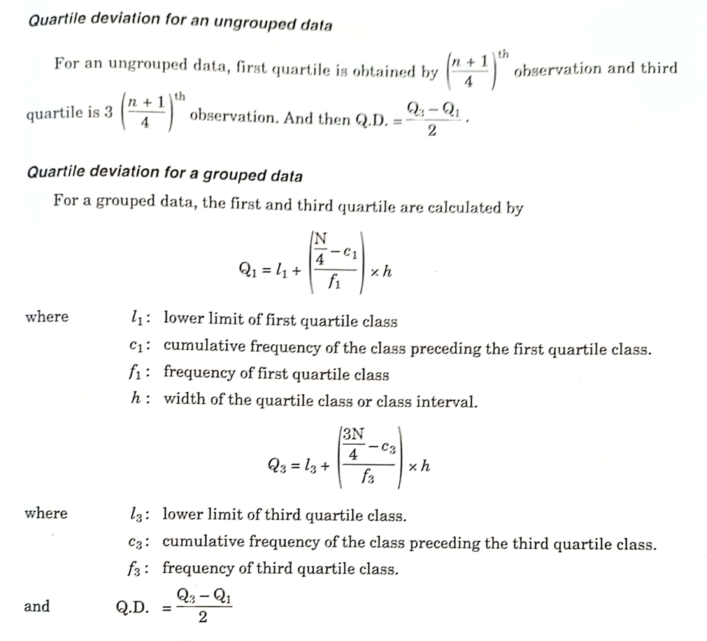

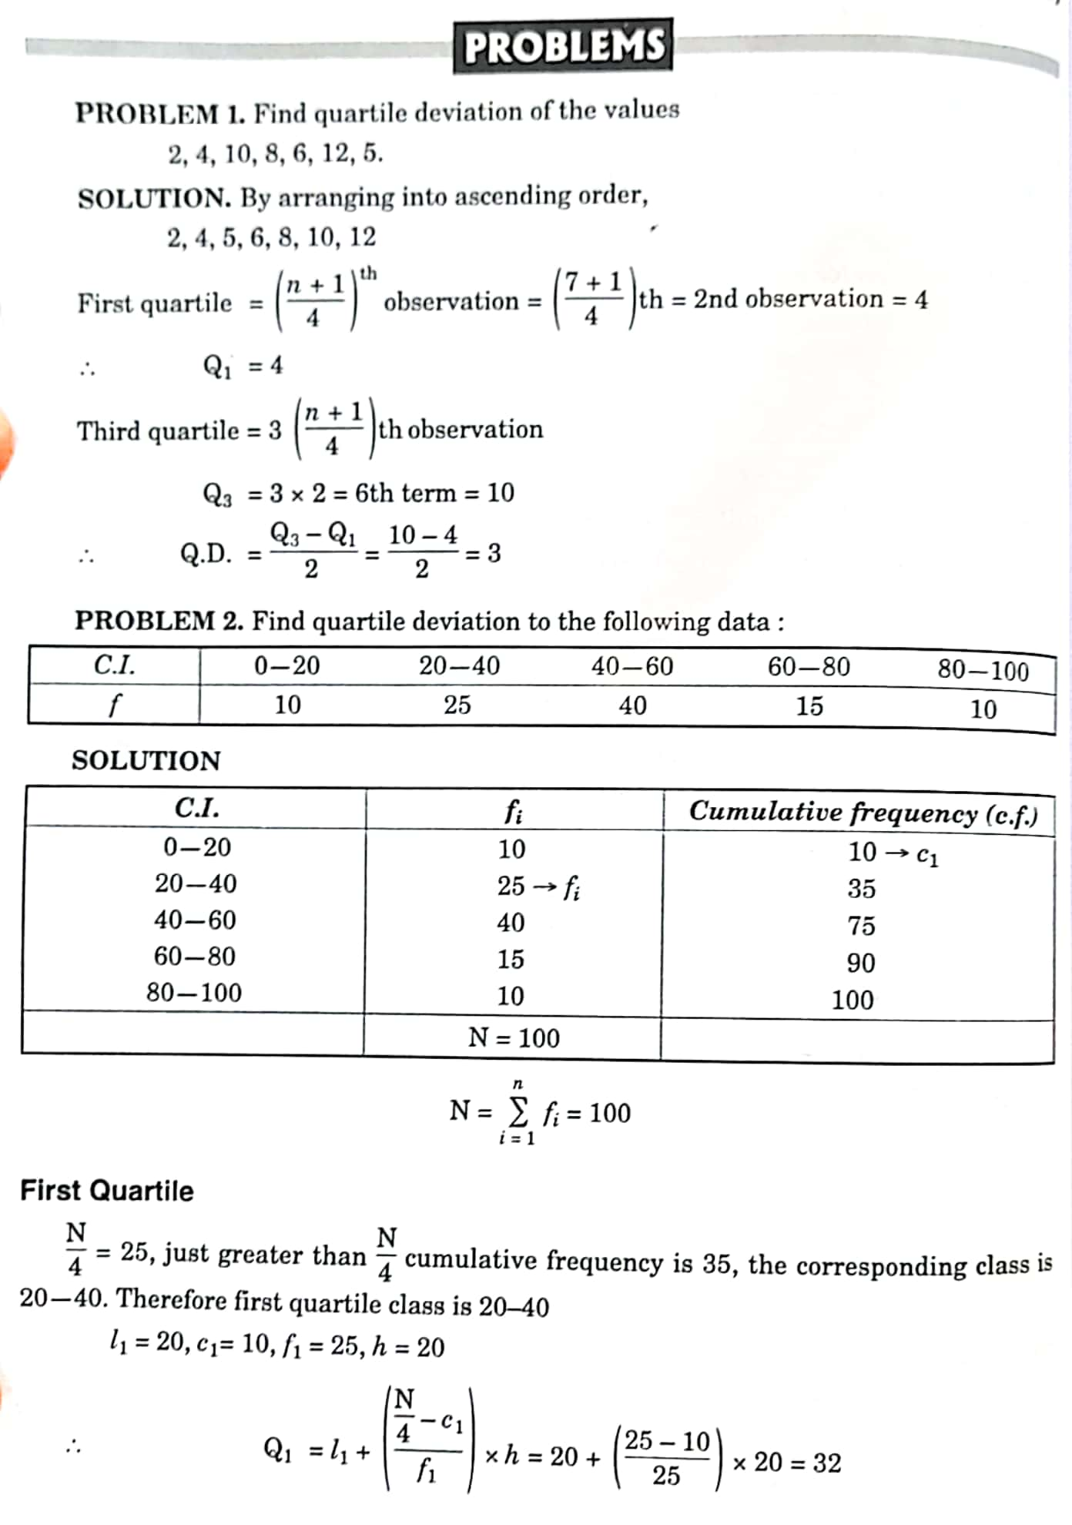
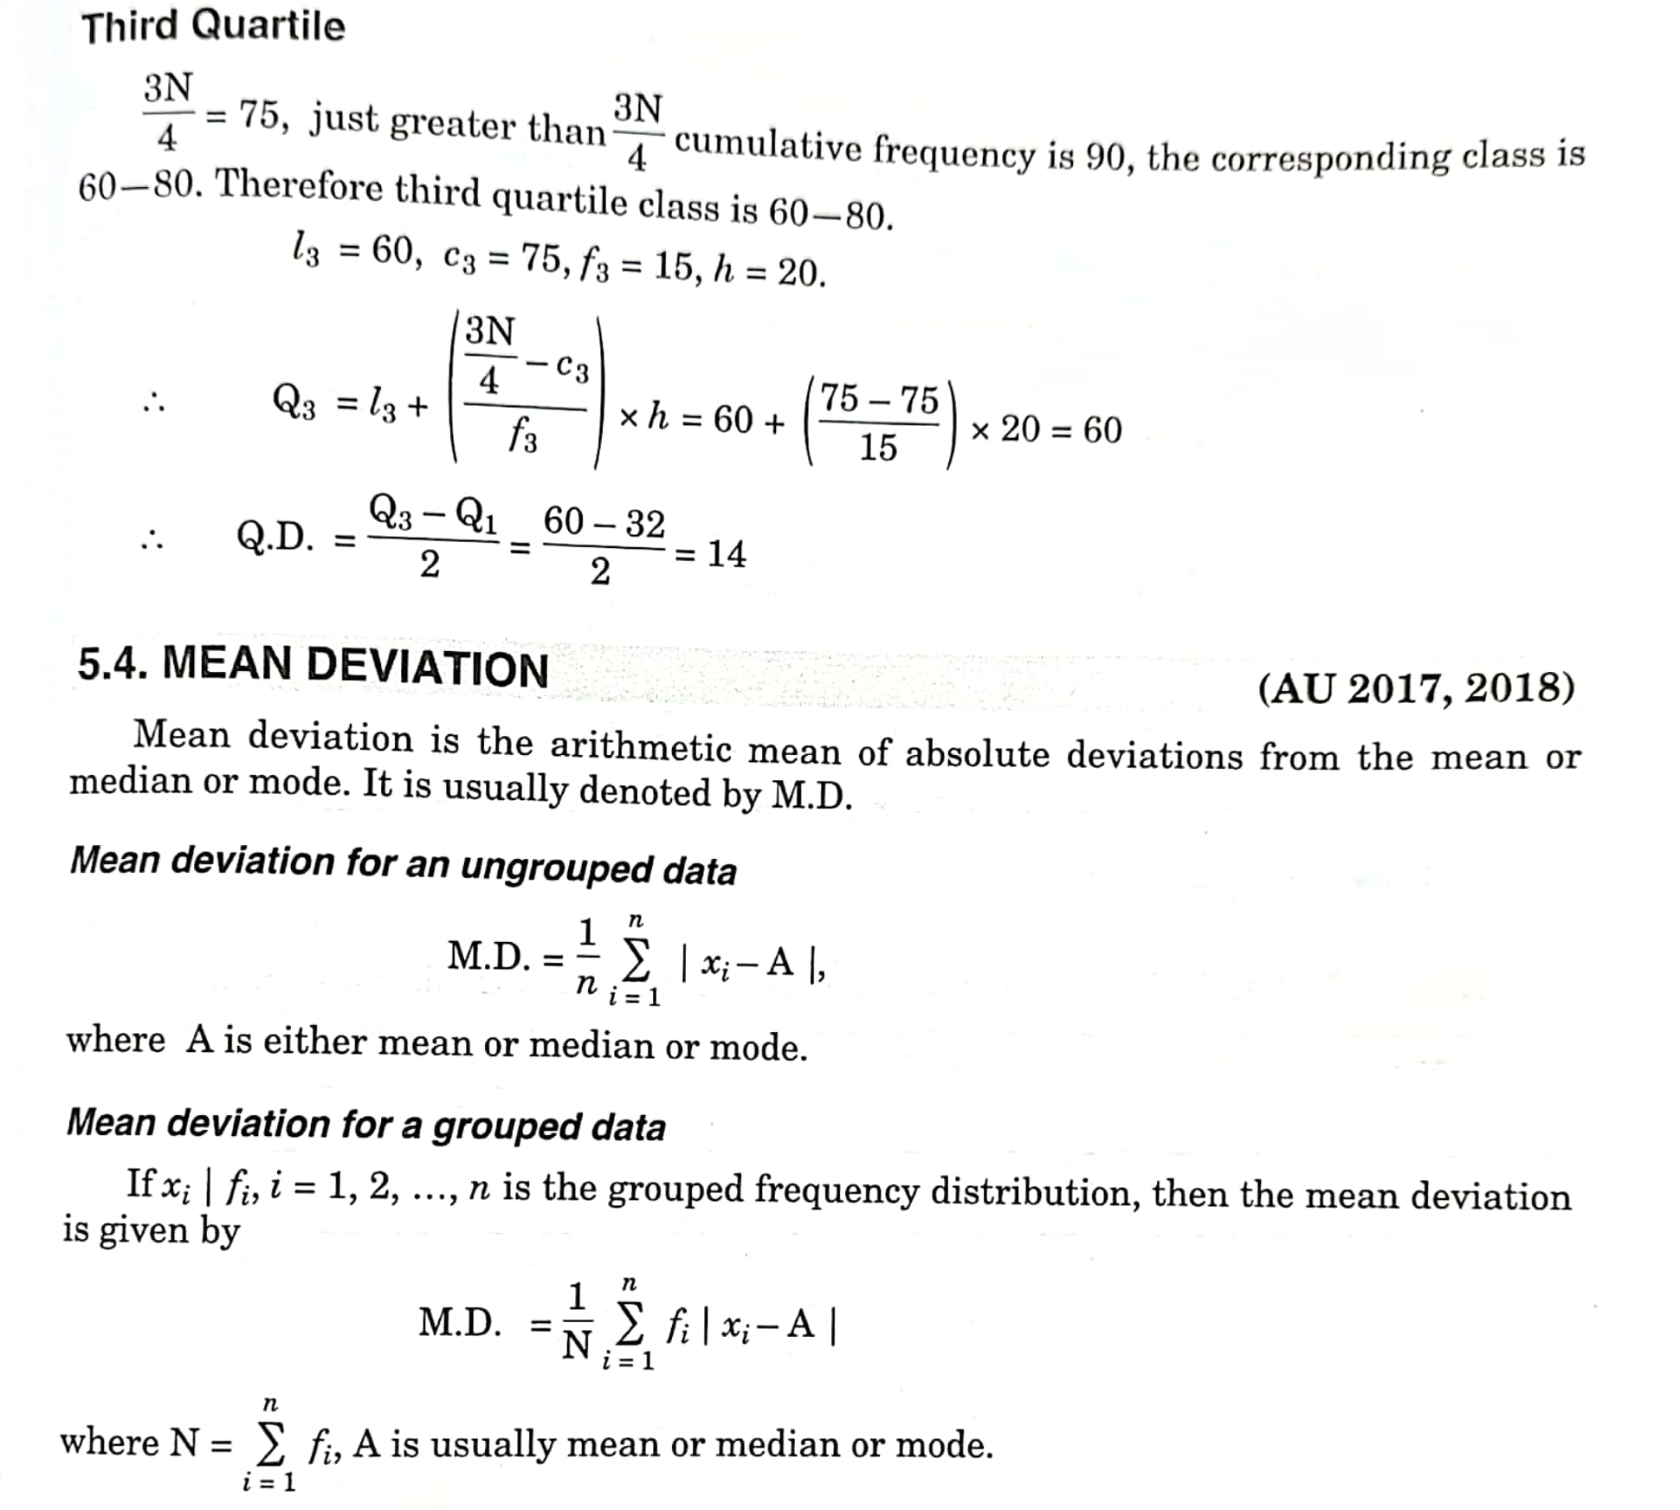
3. MEAN DEVIATION (MD):

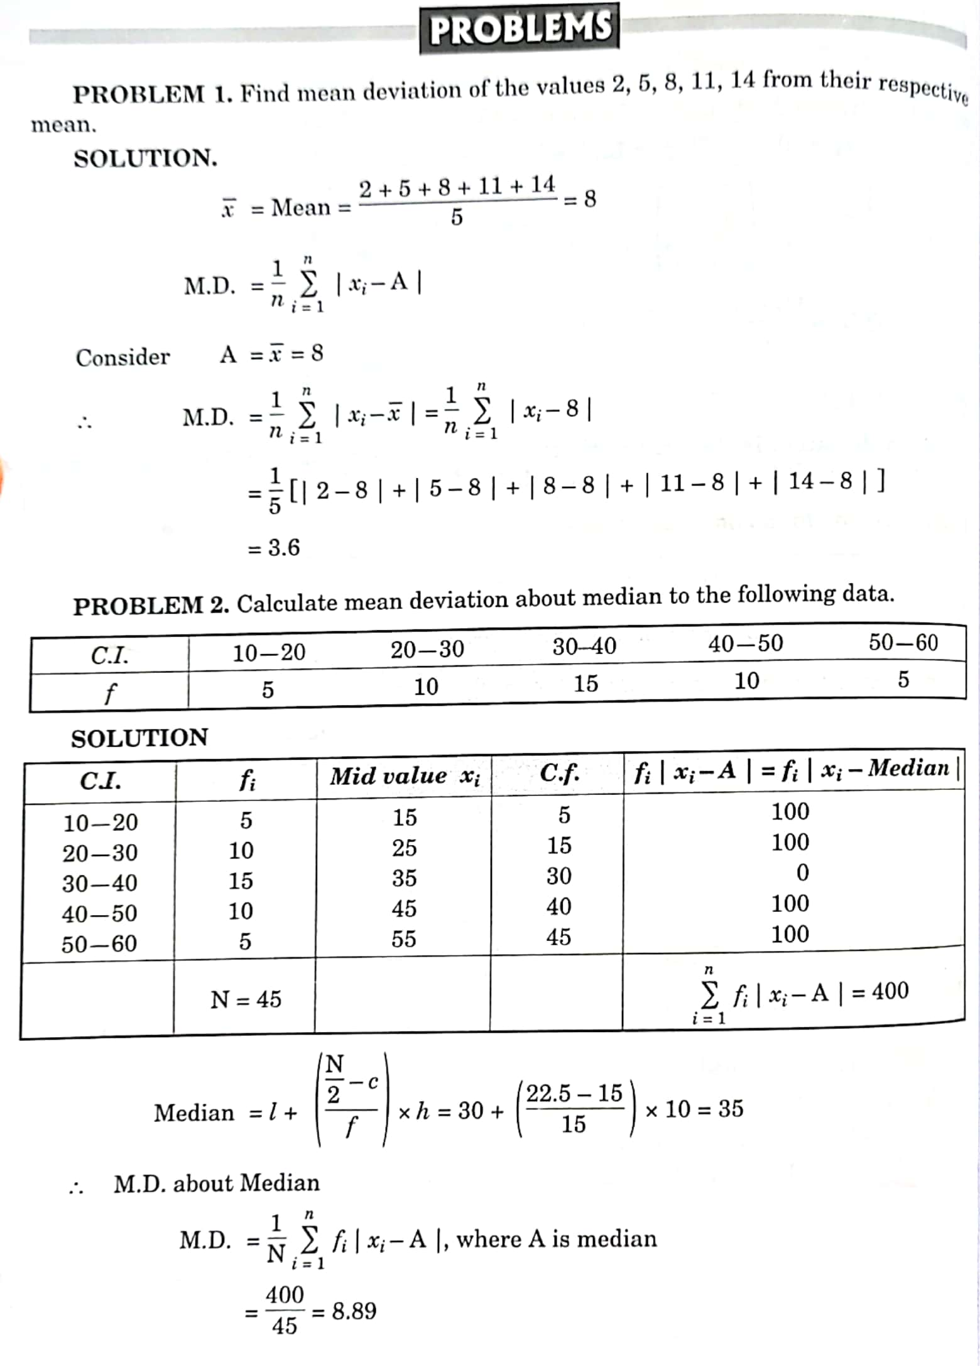

4. STANDARD DEVIATION (SD):
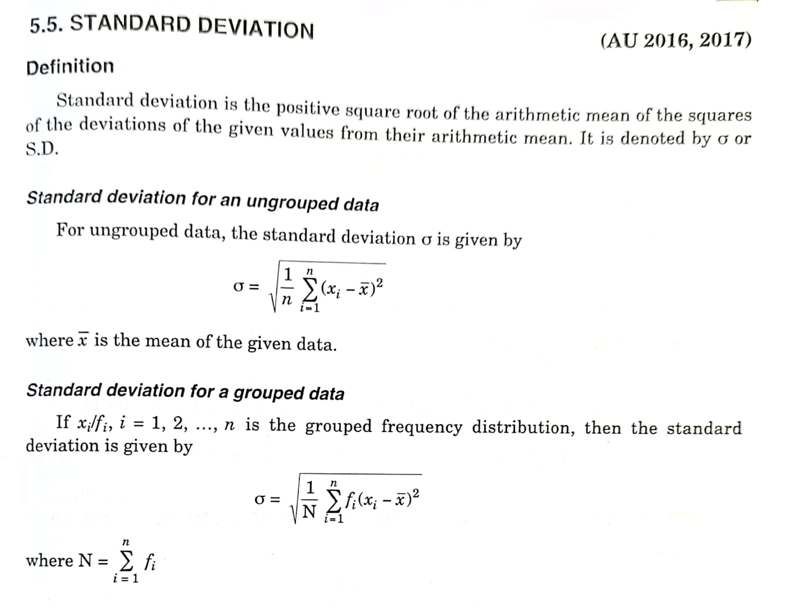
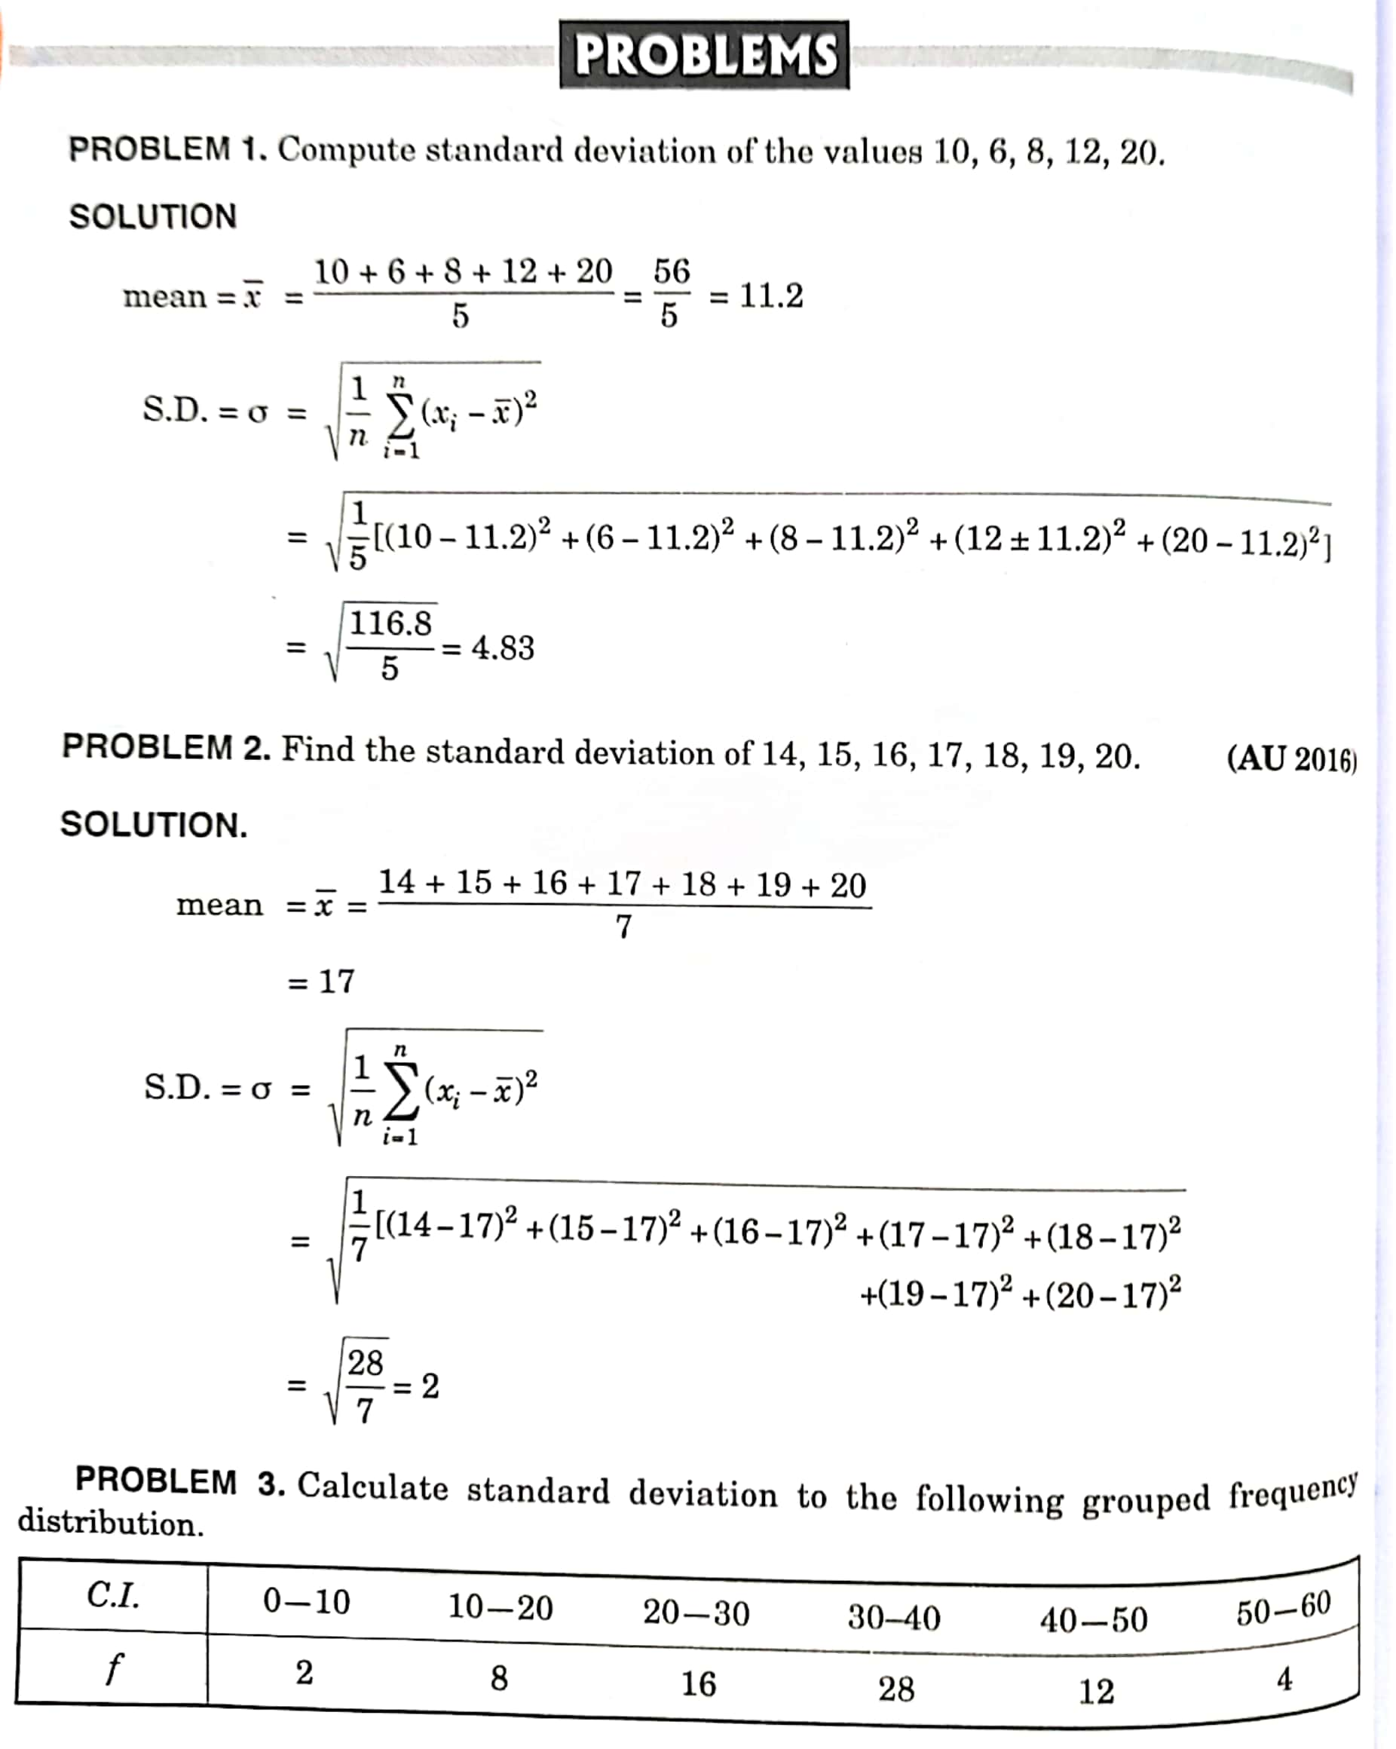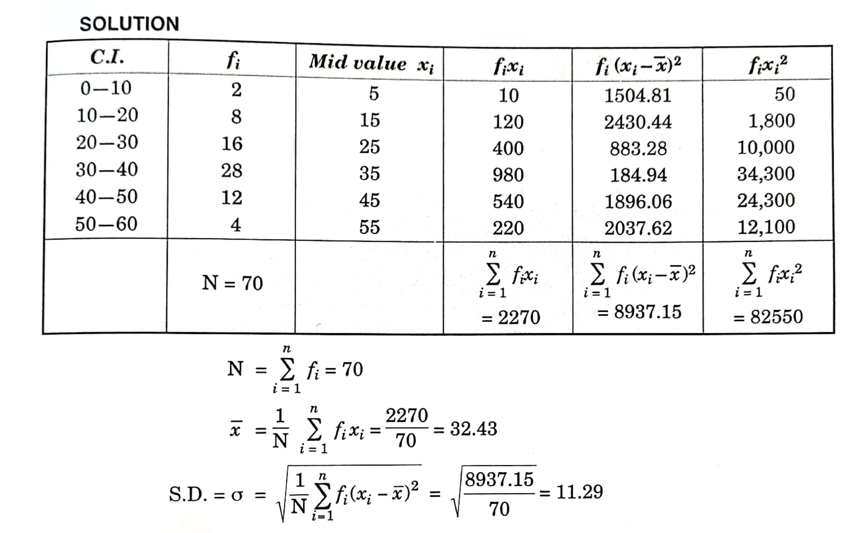
BASICS STATISTICS
MULTIPLE CHOICE QUESTIONS
1. Before any procedures for are established, the purpose and the scope of the study must be clearly specified.
  - Data analysis
  - Data tabulation
  - Data collection
  - Data selection
2. Inchon logical classification, the data is classified on the basis of:
a) Time
b) Money
c) Location
d) Quality
3. The classification of data according to location is what classification:
- Chronological
- Quantitative
- Qualitative
- Geographical
4. A function very similar to that of sorting letters in a post office is :
a) Mean
b) Standard deviation
c) Classification
d) Mean deviation
5. Adequacyofdataistobejudgedinthelightoftherequirementsofthesurveyandthe geographical areas covered by the data.
  - Collected
  - Available
  - Organized
  - Tabulated
6.Editing would also help eliminate inconsistencies or obvious errors due to treatment.
a) Characteristic
b) Arithmetical
c) Calculation
d) Tabulation
7. When an in vestigator uses the data which has already been collected by others, such data is called .
a) Primary data
b) Collected data
c) Processed data
d) Secondary data
8. ____ Provides various types of statistical information of either qualitative or quantitative nature.
- Sampling
- Tabulation
- Observation
- Editing
9. In statistics, classification groups the data according to locational differences among the items.
- Chronological
- Geographical
- Regional
- Alphabetical

10. If the class mid points in a frequency distribution of age of a group of persons are 25,32,39, 46, 53 and 60. The size of class interval is:
a)5
b)7
c)8
d)6
11.If the mid points of the classes are 16,24,32, 40, and soon, then the magnitude of the class interval is:
a)8
b)9
c)7
d)6

12. Thefirststepintabulation is:
  - Footnote
  - Sourcenote
  - Captions
  - Classification

13. Asystematic arrangementofdatainrowsandcolumnsis:
- Table
- Tabulation
- Body
- Alltheabove
14. Two dimensional diagrams used in surface diagrams are:
- Squares
- Pie diagrams
- Circles
- All the above
15. One dimensional diagram is:
- Line diagram
- Rectangles
- Cubes
- Squares

16. Typeofbardiagramis:
- Pictogram
- Sub divided diagram
- Line diagrams
- Pie diagram
17. Themost commonlyuseddeviceofpresentingbusinessandeconomicdatais:
- Pie diagrams
- Pictograms
- Bar diagrams
- Line diagrams

18. Themedianofafrequencydistributionisfoundgraphicallywiththehelp of:
- Histogram
- Frequency curve
- Frequency polygon
- Ogive

19. Themodeofafrequencydistributioncanbedeterminedgraphicallyby:
- Histogram
- Frequency curve
- Frequency polygon
- Ogive

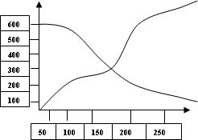
20. Findthemedianofthegivenogive:

a) 150
b) 200
c) 148
d) 175

21. Whatistheappropriatesimpleannualgrowthrateoftotalassetsbetween1990and1993?
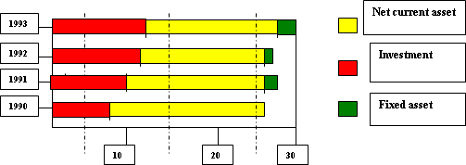
  - 36%
  - 12%
  - 9%
  - 27%

22. The equity base of the company’s remains unchanged, then the total divided earning by shareholders in 1991-1992 is:
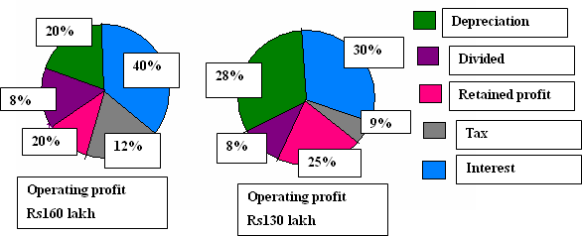
- Rs104lakh
- Rs9lakh
- Rs12.8lakh
- Rs15.6lakh

23. The standard deviation for 15,22,27,11,9,21,14,9 is:
  - 6.22
  - 6.12
  - 6.04
  - 6.32

24. The mean deviation about median from the data: 340,150,210,240,300,310,320 is:
- 51.6
- 51.8
- 52
- 52.8
25. A batsman score runs in 10 innings as 38,70,48,34,42,55,63,46,54 and 44.The mean deviation about mean is
- 8.6
- 6.4
- 10.6
- 7.6
26. Mean deviation which is calculated is minimum at:
  - Mean
  - Median
  - Mode
d) All the three

27. Find the range for the following data
14,16,16,14,22,13,15,24,12,23,14,20,17,21,22,18,18,19,20,17,16,15,11,12,21,20,
17,18,19,23.
      - 13
      - 12
c) 14
d) 16
28. Initially there were 9 workers, all being paid a uniform wage. Later a 10thworker is added to the list whose wage rate is Rs. 20 less than for others. The standard deviations of wages for the group of 10 workers are:
a) 5
b) 4
c) 7
d) 6
29. Mean of 10 items is 50 and S.D is 14. Find the sum of squares of all items
- 26543
- 26960
- 27814
- 27453

30. Standarderrorofthesamplingdistributionofa statistic is:
      - √Standard deviation
      - √Median
      - √ Variance
      - √Mean

- Questions
31. Calculate the variance of the given data set: 4,7,6,3,7,3
a) 2
b) 4
c) 6
d) 8
32. Find the median of the run made by a player in 5 T20 matches, 55,44, 21, 35, 45
a) 55
b) 21
c) 44
d) 35
33. Fin the standard deviation of the given data sets 7,2,8,11,6,13,16
a) 4.64
b) 4.34
c) 2.34
d) 3.64

34. The word ‘statistics’ is used as:
a) Singular
b) Plural
c) Singularand Plural both
d) None of the above

35. Which of the following represents data?
a) a single value
b) only two values in a set
c) a group of values in a set
d) none of the above

36. Data taken from the publication, ‘Agricultural situation in India’ will be considered as:
a) Primary data
b) Secondary data
c) Primary and secondary data
d) Neither Primary and non-secondary data

37. Statistical data are collected for,
a) Collecting data without any purpose
b) A given purpose
c) Any purpose
d) None of the above

38. For the mid-values given below
25,34,43,53,61,70 the first class of the distribution is:
a) 24.5 – 34.5
b) 25 - 34
c) 20 - 30
d) 20.5 – 29.5

39. Charts and graphs are the presentation of numerical facts by means of:
a) Points and lines
b) Area and other geometrical forms
c) Symbols
d) All the above

40. Pictograms are shown by:
a) Dots
b) Lines
c) Pictures
d) Circle

……………………………

